
EML: Customisation for the UK
Version 2.1





Document Control
Abstract
This document describes drafts of the OASIS Election Mark-up Language (EML) version 4 schemas and the additional constraints applied to for the use in UK public elections.
It is aimed at decision-makers in the election process and developers of the systems that will be used in pilots.

Date | Version | Status | Comment
2004-01-05 | 2.1 | Final | For publication.  Approved by John Borras, Office of the e-Envoy.

Date | Version | Status | Comment
2003-11-14 | 0.1 | Draft | Early draft for vendor workshop
2003-12-11 | 0.2 | Draft | Internal draft for review. Contains the nine schemas thought to be needed for CORE.
2003-12-18 | 0.3 | Draft | Schema 340 added and the results of internal review.
2003-12-18 | 2.0 | Final | For publication.  Approved by John Borras, Office of the e-Envoy.
2003-12-23 | 2.0a | Draft | Remaining schemas added. Added more definitions from the core schema. Updated Schematron rules as appropriate.

Contents

Introduction 5
Status of This Document 5
Changes from Previous Schema Version 5
Background 6
Technical Approach to UK-Locale Specification 6
Viewing Schemas 7
Schema Diagrams in This Document 7
EML Message Validation 8
Processing Using Schematron 10
Validation Using the Schematron Schemas 10
Splitting Of Messages 11
Some UK Specifics 12
Use of Names and IDs 12
Addresses 12
Responsible Officers 13
PCINs 13
The Schemas 14
All Schemas 14
Some EML Core Components 16
110 - Election Event 31
120 - Inter Database 36
130 - Response 37
210 - Candidate Nomination 39
220 - Response to Nomination 41
230 - Candidate List 42
310 - Voter Registration 43
330 - Election List 45
340 - Polling Information 47
350a - Outgoing Generic 50
350b - Incoming Generic 51
350c - Internal Generic 52
360a - Outgoing Channel Options 53
360b - Incoming Channel Options 54
410 - Ballots 55
410 - Ballots 55
420 - Authentication 58
430 - Authentication Response 59
440 - Cast Vote 60
445 - Retrieve Vote 61
450 - Vote Confirmation 62
460 - Votes 63
470 - VToken Log 64
480 - Audit Log 66
510 - Count 68
520 - Result 69
610 - Options Nomination 70
620 - Options Nomination Response 71
630 - Options List 72
References 74
Appendix A. EML-UK Transport - Proposal for Discussion 75
Message Size Limits 75
EML-UK Transport Standards 75

Introduction
This document describes the changes and additional constraints applied to the OASIS Election Mark-up Language (EML) version 4 schemas for use in UK public elections.
It is aimed at decision-makers in the election process and developers of the systems that will be used in pilots.
The additional constraints described here do not attempt to encode all business rules.
The messages that form part of EML are intended for transfer between systems. It is not intended that all outputs of an election system will have a corresponding schema.

This document and its accompanying set of schemas do not claim to satisfy the final requirements of an election system. It is incumbent on the users of this document to identify any mistakes, inconsistencies or missing data and to propose corrections to the Office of the e-Envoy.

Status of This Document
This document accompanies version 4.0g of the EML schemas and version 2.0b of the Schematron schemas. These cover the requirements of elections planned for 2004, including English and Welsh local elections, European Parliamentary elections and elections for the Greater London Assembly.
Users of this specification must ensure that it meets the requirements of specific election types. Any errors, omissions or requests for changes should be addressed to Farah.Ahmed@e-Envoy.gsi.gov.uk.

Changes from Previous Schema Version
The EML core has had some minor changes from version 4.0f described in version 2.0 of this document. The elements ContactDetails and PersonName have been added as they are required for schema 350c-internalgeneric. The definition of ResponsibleOfficer has been changed from requiring both name and responsibility to requiring either or both of these elements. The MessageType element of the EML element has been removed as this duplicated the information that was in the Id attribute of this element. The various generic communications structures have been altered. This change will have no effect on the version 4.0f schemas previously released.
There has been no change to the message schemas described in version 2.0 of this document.
The Schematron schemas have had a rule added to check that the root element of the document payload (i.e. the last child of the EML element) matches that for the message type described by the Id attribute of the EML element.

Background
The following is the Executive Summary of the ‘Election Mark-up Language (EML): e-Voting Process and Data Requirements’ [1]:
OASIS, the XML interoperability consortium, formed the Election and Voter Services Technical Committee in the spring of 2001 to develop standards for election and voter services information using XML. The committee’s mission statement is, in part, to:
“Develop a standard for the structured interchange among hardware, software, and service providers who engage in any aspect of providing election or voter services to public or private organizations….”
The objective is to introduce a uniform and reliable way to allow election systems to interact with each other. The overall effort attempts to address the challenges of developing a standard that is:
- Multinational: our aim is to have these standards adopted globally
- Flexible: effective across the different voting regimes. E.g. proportional representation or ‘first past the post’.
- Multilingual: flexible enough to accommodate the various languages and dialects and vocabularies.
- Adaptable: resilient enough to support elections in both the private and public sectors.
- Secure: able to secure the relevant data and interfaces from any attempt at corruption, as appropriate to the different requirements of varying election rules.

The primary deliverable of the committee the Election Mark-up Language (EML). This is a set of data and message definitions described as XML schemas. At present EML includes specifications for:

- Candidate Nomination, Response to Nomination and Approved Candidate Lists
- Voter Registration information, including eligible voter lists
- Various communications between voters and election officials, such polling information, election notices, etc.
- Logical Ballot information (races, contests, candidates, etc.)
- Voter Authentication
- Vote Casting and Vote Confirmation
- Election counts and results
- Audit information pertinent to some of the other defined data and interfaces

As an international specification, EML is generic in nature, and so needs to be tailored for specific election scenarios. Some aspects of the language are indicated in EML as required for all election scenarios and so can be used unchanged. Some aspects (such as the ability to identify a voter easily) are required in some scenarios but prohibited in others, so EML defines them as optional. Where they are prohibited, their use must be changed from an optional to prohibited classification, and where they are mandatory, their use must be changed from an optional to required classification. The technical approach to achieving this is described below.

Technical Approach to UK-Locale Specification
EML is described as a process [1] and set of schemas. These schemas adhere to the W3C XML Schema recommendation [2].
For this application, the name and address formats will be changed to the UK GovTalk Address and Personal Details [3] formats by replacing the EML externals file with one specifically for the UK.

Other changes are described in this document in text format and schemas are provided using the Schematron language [8]. This is currently in the process of being adopted by the International Organization for Standardisation (ISO) and the International Electrotechnical Committee as part of the ISO/IEC Document Schema Definition Languages (DSDL) or ISO/IEC 19757 standard [9].

Viewing Schemas
EML schemas are supplied as text documents. For viewing the structure of the schemas, we recommend use of one of the many schema development tools available. Many of these provide graphical displays.
The Schematron schemas are mainly short and simple to understand as text documents for those with a working knowledge of XPath [10].

Schema Diagrams in This Document
The schema diagrams in this document were created using XML Spy. The following is a guide to their interpretation.
In this section, terms with specific meanings in XML or XML Schema are shown in italics, e.g. sequence.
Note that the diagrams in this document do not use the default diagramming options of XML Spy, but have additional information. The additional information to be shown can be set using the menu selections Schema Design | View Config.
The diagram below represents a simple schema. The root element of the schema is the element A. The content model of this element is a sequence of the elements B, D and E. The element B is of complex data type Bstructure. This contains a choice of either element C or element F. Element C is a restriction of another complex data type Cstructure. In this case, the restriction is to forbid the use of the element G (which is defined in Cstructure as optional). The other elements allowed are H, which can appear any number of times (but must appear at least once), and I, which can appear up to three times (or not at all). Element D is optional, and of data type Dstructure. This has a content model requiring all of elements J and K, which are both of type xs:string. Finally, element E is of simple data type Etype, which is restricted from the xs:NMTOKEN data type by only allowing the values ‘yes’ and ‘no’.
It is important to remember that these diagrams do not include any attributes.
The full schema is shown below the diagram.
the element is crossed out as the restriction is to forbid its occurrence
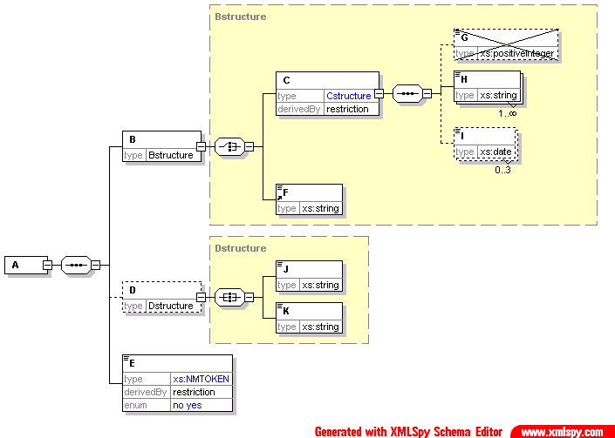
indicates that this is an ‘all’
shows the data type
a data type in blue shows a derivation, in this case, a restriction
indicates one to many occurrences
indicates zero to three occurrences
the data type is in blue, so this is a derivation. The derivation is to allow only the values ‘yes’ or ‘no’
indicates that this is a choice
indicates that this is a sequence
The yellow box represents the content model of the complex data type (in this case, Bstructure)
dotted box around element indicates that element is optional

<?xml version="1.0" encoding="UTF-8"?>
<!-- edited with XMLSPY v2004 rel. 2 U (http://www.xmlspy.com) by Paul Spencer (Boynings Consulting) -->
<xs:schema xmlns:xs="http://www.w3.org/2001/XMLSchema" elementFormDefault="qualified" attributeFormDefault="unqualified">
<xs:element name="A">
<xs:complexType>
<xs:sequence>
<xs:element name="B" type="Bstructure"/>
<xs:element name="D" type="Dstructure" minOccurs="0"/>
<xs:element name="E">
<xs:simpleType>
<xs:restriction base="xs:NMTOKEN">
<xs:enumeration value="no"/>
<xs:enumeration value="yes"/>
</xs:restriction>
</xs:simpleType>
</xs:element>
</xs:sequence>
</xs:complexType>
</xs:element>
<xs:complexType name="Bstructure">
<xs:choice>
<xs:element name="C">
<xs:complexType>
<xs:complexContent>
<xs:restriction base="Cstructure">
<xs:sequence>
<xs:element name="G" type="xs:positiveInteger" minOccurs="0" maxOccurs="0"/>
<xs:element name="H" type="xs:string" maxOccurs="unbounded"/>
<xs:element name="I" type="xs:date" minOccurs="0" maxOccurs="3"/>
</xs:sequence>
</xs:restriction>
</xs:complexContent>
</xs:complexType>
</xs:element>
<xs:element ref="F"/>
</xs:choice>
</xs:complexType>
<xs:complexType name="Cstructure">
<xs:sequence>
<xs:element name="G" type="xs:positiveInteger" minOccurs="0"/>
<xs:element name="H" type="xs:string" maxOccurs="unbounded"/>
<xs:element name="I" type="xs:date" minOccurs="0" maxOccurs="3"/>
</xs:sequence>
</xs:complexType>
<xs:complexType name="Dstructure">
<xs:all>
<xs:element name="J" type="xs:string"/>
<xs:element name="K" type="xs:string"/>
</xs:all>
</xs:complexType>
<xs:element name="F" type="xs:string"/>
</xs:schema>

EML Message Validation
The combination of the EML schemas, Address and Personal Details (APD) schemas [3], the EML externals schema and the Schematron schemas provides the normative definition of the messages to be used in this application. This provides a clear separation between the international EML specifications and the additional constraints used for UK local elections.
Note that the EML externals schema references the APD schemas assuming they are all in the same directory. For validation to work, either the schemas must be placed in the location expected or the path changed in the EML externals schema.
It is up to each specific system implementation whether it uses these schemas for validation of EML messages for either testing or live use. The recommended approach is to validate incoming messages against the EML schemas (with the application-specific EML externals schema), then further validate against the relevant Schematron schema. The first stage requires the use of an XML processor (parser) that conforms to W3C XML Schema. The second stage requires either an XSLT processor or a dedicated Schematron processor.
However, an implementation may choose to:
- modify the EML schemas to incorporate those application-specific constraints that can be represented in W3C XML Schema;
- not validate these changes;
- not perform any validation; or
- develop some alternative validation.

However, one purpose of the pilots over the next few years is to test both EML and this mechanism of customisation. The Office of the e-Envoy will welcome feedback on the use of this mechanism.

Processing Using Schematron
This section gives a short introduction to how validation can be achieved using Schematron schemas and an XSLT processor. Alternatively, direct validation using the Schematron schemas can be achieved using a dedicated Schematron processor.

Validation Using the Schematron Schemas
A Schematron schema is an XML document that can be converted to XSLT using an XSLT stylesheet.
There is a published stylesheet (skeleton1-5.xslt) that can be used to achieve this. This produces an HTML output from the validation. For EML-UK, we prefer to create an XML file conforming to the 130-response schema to report errors, and convert this for display as a separate process. A separate stylesheet can be produced that will create an output to the specification below. This stylesheet can import the skeleton and just over-ride those aspects where changes are required.
This stylesheet can be used once on each Schematron schema to produce the XSLT file that will be used for validating a specific message type. This stylesheet is then used to transform the incoming EML message into an error report based on the additional EML-UK constraints.
The process is shown in the diagram below.
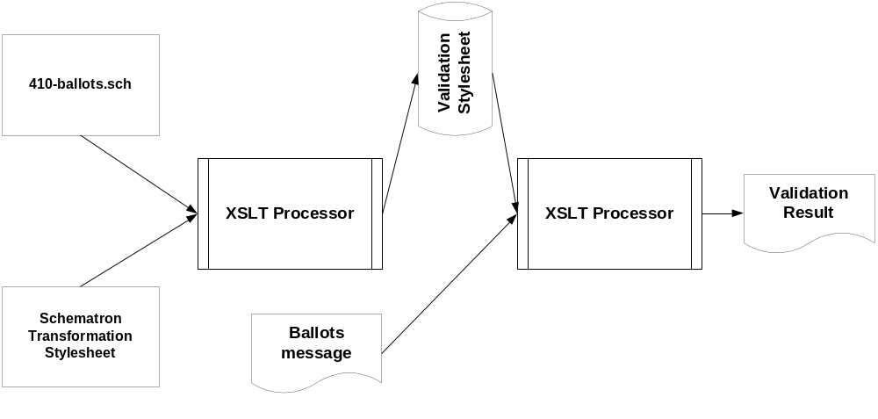

Splitting Of Messages
There is sometimes a need to split long messages into several parts. By their nature, each of these messages will contain a small amount of background information and a single element type that is repeated many times. For example, the 460-votes message can have many CastVote elements.
When a message is split, each part must be a complete, valid message. This will contain all the background information with a number of the repeated element types. Information in the EML element indicates the sequence number of the message and the number of messages in the sequence. Each message in the sequence must contain the same TransactionId, and must indicate the repeated element according to the table below. Only the messages shown in the table may be split in this way.

Message | Repeated Element
330-electionlist | Voter
340-pollinginformation | Polling
410-ballots | Ballot
460-votes | CastVote
470-vtokenlog | VToken or VTokenQualified
480-auditlog | LoggedSeal

Use of Names and IDs

Some UK Specifics
EML requires the use of various identifiers, both as textual names and as Id attributes. In some cases, the names and Id attributes must be unique, in others; they must be common, possibly across several system suppliers. For example, for a European Parliamentary election, several authorities might be responsible for organising voting, whilst one is responsible for organising the count. In this case, it is likely to be important that all authorities use the same identifiers for candidates.
It is the responsibility of the senior responsible officer to ensure that suitable identifiers are assigned. Where identifiers must be unique, they should be prefixed with the local authority code [4] followed by a hyphen. If several authorities are involved, the code to be used is the one of the authority responsible for the contest.

Addresses
EML allows two address types - structured and mailing. The former is used where it is possible and beneficial to use a BS7666 address, for example, to determine whether a voter lives within a specific constituency. The latter is used when this is not necessary (for example, if it is just used to send post), or if it is not possible (for example, the candidate for a European Parliamentary election might live overseas and so not have a BS7666 address).
The two address formats are described in the Government Data Standards Catalogue [12]. All addresses must use either the post code or the unique property reference number (UPRN) or both.

 | structured | mailing | comment
voter electoral address | ✓ |  | If the full BS7666 address cannot be found, the BS7666 address format should be used without the UPRN.
voter previous electoral address | ✓ |  | If the full BS7666 address cannot be found, the BS7666 address format should be used without the UPRN.
agent's official address |  | ✓ | This is a mailing address as the agent may be overseas.
candidate's qualifying address |  | ✓ | This is a mailing address as the candidate may live overseas for European Parliamentary elections.
authority address | ✓
polling places address | ✓
proxy address |  | ✓
candidate contact address |  | ✓
voter contact address |  | ✓
agent contact address |  | ✓
proposer address |  | ✓
responsible officer address |  | ✓

Responsible Officers
Responsible officers may be assigned at several levels (event, election, contest, reporting unit). In some cases, officers will only be required at some of these levels.
The following example indicates senior responsibilities for the different types of election that might be held simultaneously in the London Borough of Kensington and Chelsea. It is not a complete list of officers, and is not intended as a definitive list, but rather as an illustration.

 | Event | Election | Contest | Reporting Unit
Mayor | BRO (Kensington and Chelsea) | GLRO |  | CRO (BRO, Westminster)
London Assembly (London-wide) | BRO (Kensington and Chelsea) | GLRO |  | CRO (BRO, Westminster)
London Assembly (West Central constituency) | BRO (Kensington and Chelsea) | GLRO | CRO (BRO, Westminster) | CRO (BRO, Westminster)
European | LRO (BRO, Kensington and Chelsea) |  | London RRO | CRO (BRO, Westminster)

BRO | Borough Returning Officer
CRO | Constituency Returning Officer
GLRO | Greater London Returning Officer
LRO | Local Returning Officer
RRO | Regional Returning Officer

PCINs
Appendix C of the e-Voting Security Study [11] describes a method of voting using Personal Candidate Identification Numbers and Expected Responses. This mechanism is supported in EML using the ShortCode and ExpectedResponse attributes that can be attached to entities for which votes can be cast.

The Schemas
This section describes the EML messages and how the message specifications change for this application. It is based on EML version 4, and uses the element and attribute names from the schemas.
Error messages are given codes. These fall into one of five series:

1000 | XML well-formedness or Schema validation error
2000 | Seal error
3000 | EML rule error
4000 | Localisation rule error
5000 | System specific error
If the error type is not message-specific (or is a general rule applying to several schemas), the series reference above is used. If it is message-specific, the last three digits of the error series (and possibly a final alpha character) reflect the message type. A three digit error code is appended to the series code, separated by a hyphen.
An error code relating to a localisation applicable to all message types could therefore be 4000-001. One specific to the localisation of schema 110 could be 4110-002.

All Schemas

XML well-formedness or Schema validation error
Error code | Error Description
1000-001 | Message is not well-formed
1000-002 | Message is not valid

Seal Errors
Error code | Error Description
2000-001 | The Seal does not match the data

EML Schematron Rules
The following rules apply to messages regardless of localisation. A suitable value is substituted for ‘xxx’. One of the two rules on splitting will apply to each message type as described in the table below.

Error Code | Error Description
3000-001 | If there are processing units in the AuditInformation, one must have the role of sender
3000-002 | If there are processing units in the AuditInformation, one must have the role of receiver
3000-003 | This message must not contain the elements used for splitting
3000-004 | The value of the Id attribute of the EML element is incorrect
3000-005 | The message type must match the Id attribute of the EML element
3xxx-xxx | All messages that are split (see page 10) must include the correct sequenced element name.

 | 3000-003 | 3xxx-xxx
110 | ✓
120 | ✓
130 | ✓
210 | ✓
220 | ✓
230 | ✓
310 | ✓
330 |  | ✓
340 |  | ✓
350a | ✓
350b | ✓
350c | ✓
360a | ✓
360b | ✓
410 |  | ✓
420 | ✓
430 | ✓
440 | ✓
445 | ✓
450 |  | ✓
460 |  | ✓
470 |  | ✓
480 |  | ✓
510 | ✓
520 | ✓
610 | ✓
620 | ✓
630 | ✓

EML-UK Explanation and Rules
The following rules apply to all messages:
Error Code | Error Description
4000-001 | A Seal must be present
4000-002 | The election rule ID is not used
4000-003 | If a seal is of type OtherSeal, the Type attribute must have a value of RFC2630 or RFC3161
4000-004 | There must be at least one child of a contact element
4000-005 | The address must contain either a UPRN (if it is a BS7666 address) or a post code (or both)
The following rules apply to the messages specified in the table below:
Error code | Error Description
4000-101 | Where there can be an AuditInformation, it is mandatory and must have at least one ProcessingUnit.
4000-102 | All messages from the voter, candidate or proposer must include an element to indicate the language required for the response.

 | 4000-101 | 4000-102
110
120
130
210 |  | ✓
220
230
310 |  | ✓
330
340
350a
350b |  | ✓
350c
360a
360b |  | ✓
410
420 |  | ✓
430
440 | ✓ | ✓
445 | ✓
450
460 | ✓
470 | ✓
480 | ✓
510 | ✓
520
610 |  | ✓
620
630

Some EML Core Components
All the following exist as data types. Where they also exist as elements, these are shown instead. Where they do not, the data type is shown (indicated by the suffix ‘Structure’). To help message schema diagrams fit on the page, these elements and data types are not expanded each time they appear in other diagrams.

Affiliation

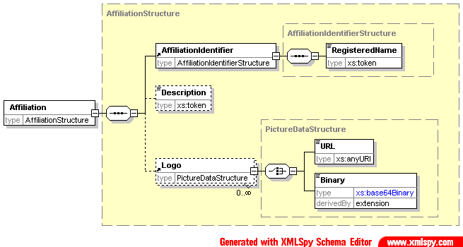The affiliation element indicates membership of some organization such as a political party. The identifier indicates the official name and ID of the organisation. The description will usually be used to indicate the name usually associated with the organisation, and so is the value that will usually be shown on a ballot paper. An organisation may indicate several logos, each with a rôle. For example, one rôle might indicate that the logo should be used on a ballot paper. Each logo can be identified by a URL or sent as a Base64 encoded binary value. In the latter case, the format of the logo (PNG, GIF or JPEG) must be indicated.

Agent
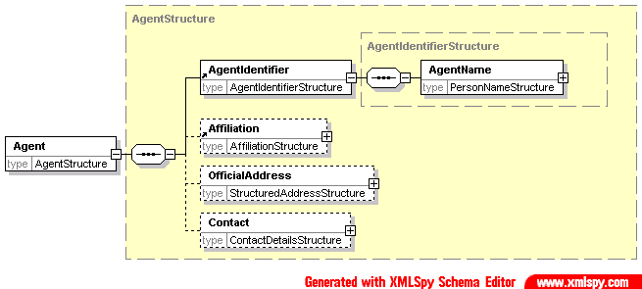
A candidate in an election can have one or more agents, each agent having a specific rôle. For example, an agent may be allowed access to the count, but not to amend details of the candidate.
The agent has an identifier, comprising a name and ID, and an affiliation. He or she also has an official address and a standard set of contact details.

AuditInformation

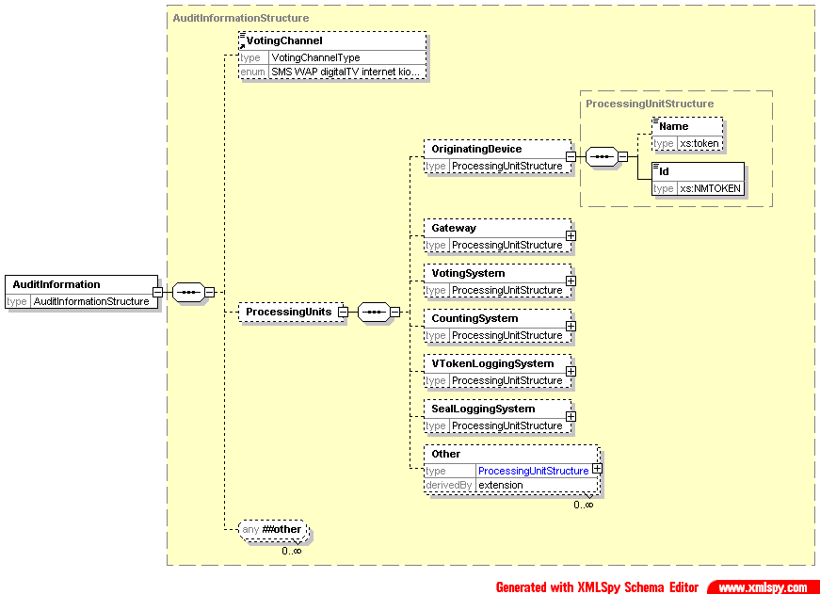
This element is used to provide information for audit purposes. It allows the voting channel in use to be described, with the identities of those devices that have participated in the message being sent. Each device has an attribute to describe its rôle. The rôle can be "sender", "receiver", "previous sender" or "next receiver". The latter two are used when there is a gateway involved. For example, a 440 (cast vote) message might have an OriginatingDevice as its original sender, a gateway as sender and voting system as receiver.
Where a device does not fit any of the categories here, it can be described as Other with the addition of a Role attribute.

Candidate

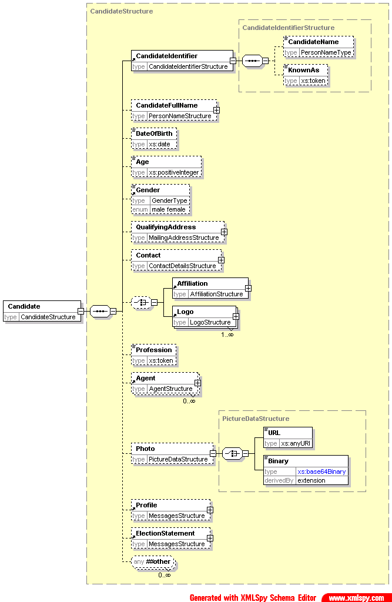The candidate description includes all the information required about the candidate. In different messages, the amount of information is reduced, either by restricting the information in EML or as part of a localisation.
The candidate identifier indicates a system ID for the candidate and the candidate's name as it will appear in a ballot. Sometimes an additional line is required on the ballot to help identify the candidate. This will use the KnownAs element of the candidate identifier. A short code can also be included, either for SMS voting or where the security mechanism in place requires it. An ExpectedConfirmationReference attribute also allows for security mechanisms where the confirmation reference may be different for each combination of voter and candidate. The full name of the candidate may also be provided. The meaning of much of the other information is clear from the diagram above. The candidate profile describes the candidate. The election statement describes the opinions of the candidate. Optionally, a photo may be included, either as a link or as BASE64 encoded binary.

UK Specifics
If the voting mechanism from Appendix C of the e-Voting Security Study [11] is being used, the ShortCode attribute of the CandidateIdentifier element holds the PCIN and the ExpectedConfirmationReference attribute holds the expected Response.

ContactDetails

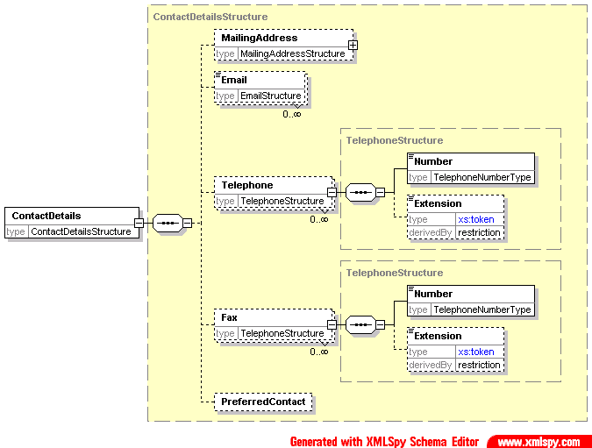This element and its associated data type are used in many places throughout the EML schemas. The mailing address uses whatever format is defined in the EML externals schema document. Where several addresses or numbers can be given (for example, email addresses), there is a facility to indicate whichever is preferred. The overall preferred method of contact can also be provided using an xlink:href attribute in the PreferredContact element.

UK Specifics
The mailing address uses the APD InternationalAddressStructure data type.

ElectionIdentifier

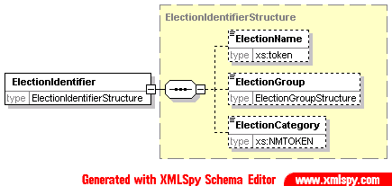The election identifier is used wherever the election needs to be specified. There is an Id attribute, which can often be used on its own to identify the election. In other cases, particularly where the content of a message is to be displayed, the election name can also be provided. The election group is used to group a number of elections together. This could be required, for example, under the additional member system, where two elections are held, the result of one influencing the result of the other. It could also be used at a company AGM, where proposals might be grouped for display purposes.
The election category is used in messages where several elections are included in the message, but may be treated differently under localisation rules. Each election that requires different treatment will be given a category unique within that election event, allowing a Schematron processor to distinguish between the elections.
ManagingAuthority

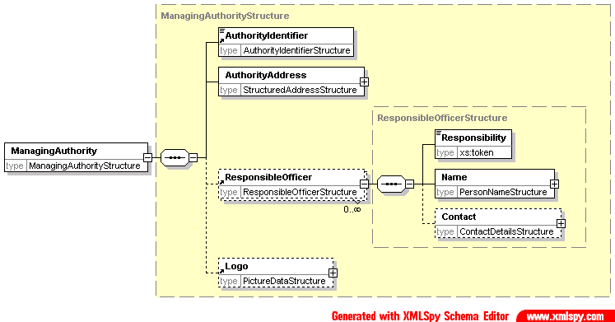The managing authority is the body responsible for an election event, election, contest or reporting unit. In most cases, not all of these will be required, but sometimes more than one is necessary. For example, an election using the additional member system might be organized on a regional basis, whilst local authorities organise their local election events. In this case, the region becomes the managing authority for the contest, whilst the local authority is the managing authority for the event. There will also be an authority responsible for the overall conduct of the election, although this information might not be required.
The managing authority indicates the authority name, address, Id, any logo that might be required for display during the election and a list of responsible officers. Each responsible officer has a name, responsibility (such as ‘returning officer’) and contact information. Local rules will usually indicate the values allowed in the Responsibility element.

UK Specifics
The authority ID code must come from the document ‘Standard Names and Codes for administrative and electoral geographies in the UK (SNAC)’ [4].

MessagesStructure

The Message data type is of ‘mixed’ type, so can have both text and element content. The intention is that it should have one or the other. The element using this data type can indicate the language of the messages using the xml:lang attribute. The Message element has two attributes: Format indicates the format of element content, for example, XHTML, and Type indicates the purpose of the message.

PictureDataStructure

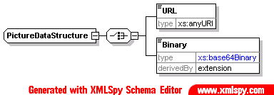Where a picture (logo, map, photo) is provided, it may be given as either a link or as Base64 encoded binary data. In the latter case, the format of the logo (BMP, PNG, GIF, JPEG or TIFF) must be indicated.

PollingPlace

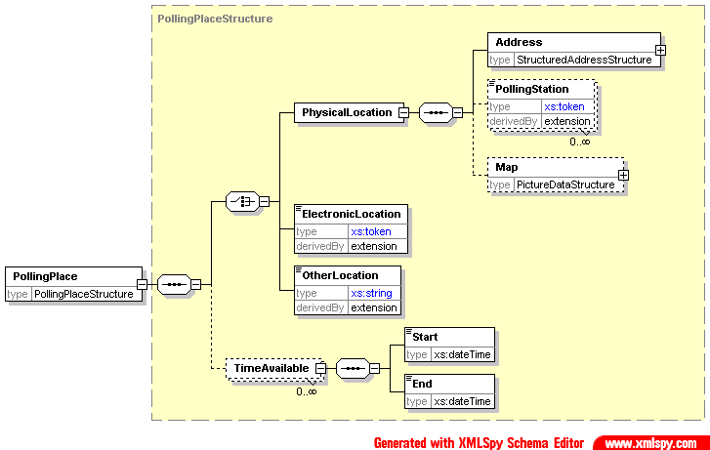In general, a polling place will be either a physical location (polling station or postal vote address) or an electronic location (for Internet, SMS, telephone and other electronic means of voting). However, it is possible that neither of these types will meet every need, and so an OtherLocation element has been included. Each of these locations must indicate the channel for which it is to be used. If a single location supports multiple channels, it must be included multiple times.
A physical location has an address. Sometimes, several polling stations will be at the same address, so a polling station can be defined within the address. Access to an external map can also be provided as a URI or Base64 encoded binary data.
An electronic location must indicate its address (e.g. phone number, URL).
An optional TimeAvailable element is also provided. In most cases, this is not required as the time a location is available is the same as the time the channel is available. However, there are circumstances, such as the use of mobile polling stations, where this is not the case.

Proposal

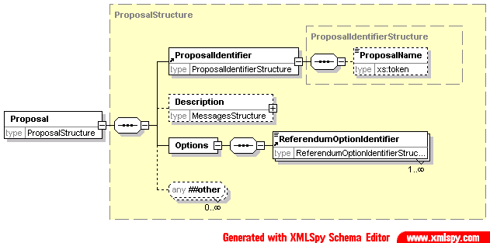A proposal is used in a referendum. At a basic level, it is a piece of text with the options (‘yes’ and ‘no’, ‘for’ and ‘against’ etc) to be voted on.
The proposal identifier provides a name and ID. The description is used to provide the information that will be displayed to the voter to indicate the aim of the proposal. The options are then used to indicate how the voter may vote.

Proxy

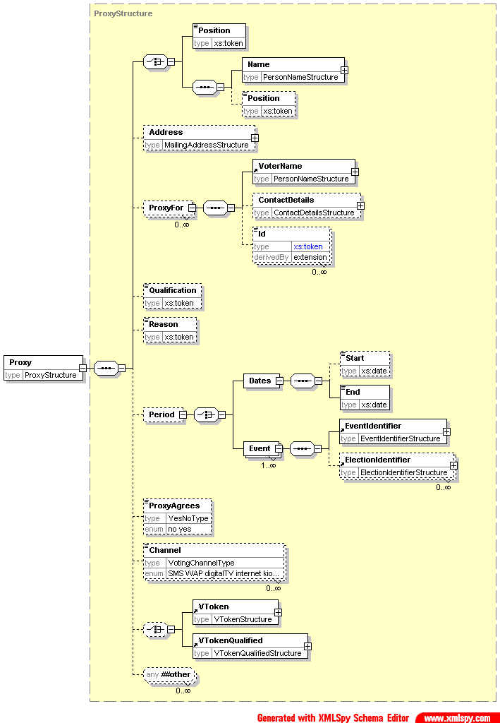In many elections, a voter may appoint a proxy to vote on his or her behalf. That proxy may be identified by position (for example, appointing the chairman as proxy at a company AGM), or by name (for example, appointing your spouse as proxy for a public election), or both.
In some elections, the proxy must, for example, be a family member. This is indicated using the Qualification element, while a reason for appointing a proxy can be indicated using the Reason element.
A proxy can be appointed for one or more election events (and individual elections within each event) or for a period of time. A proxy may be limited to voting only over certain channels. A proxy may also have a voting token, indicating the right to vote, or a qualified voting token, indicating that there is a question over their right to vote.

ResponsibleOfficer
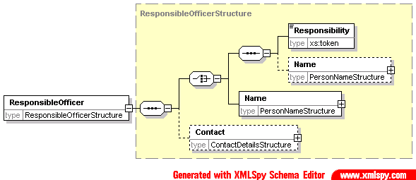
A responsible officer is someone who has some sort of rôle to play in the organization of an election. A responsible officer is defined by his or her name and responsibility (or both) and has contact information.

Seal

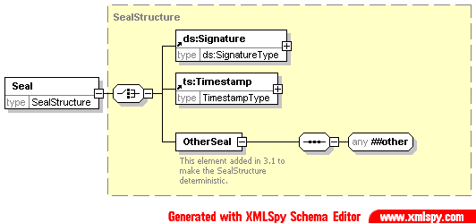The seal is used to protect information such as a vote, voting token or complete message. The seal provides the means of proving that no alterations have been made to a message or individual parts of a message such as a vote or collection of votes, from when they were originally created by the voter. The seal may also be used to authenticate the identity of the system that collected a vote, and provide proof of the time at which the vote was cast.
If a message is to be divided, each part must be separately sealed to protect the integrity of the data. For example, if votes in several elections are entered on a single ballot, and these votes are being counted in separate locations, each vote must be separately sealed.
A seal may be any structure which provides the required integrity characteristics, including an XML signature [5] or a time-stamp.
The XML signature created by the voting system provides integrity and authentication of the identity of the system that collected the vote. The time-stamp provides integrity of the vote and proof of the time that the vote was cast.

UK Specifics
EML allows for various types of seal, and does not mandate any particular security algorithm or parameters. To conform to the requirements of UK public elections, all seals must be verifiable by a third party and may conform to either type specified in EML, or RFC 2630 [6] and RFC 3161 [7]. Systems that generate seals must provide a tool kit and any supporting data, such as certificates, that allow the third party to validate the seal. This tool must be made available free of any licence cost.

VoterIdentificationStructure

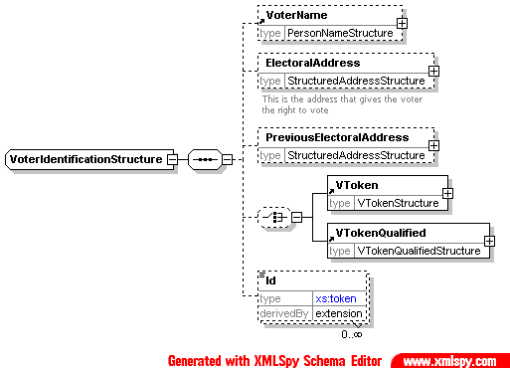This is used wherever identification of a voter is required. It contains the voter's name and electoral address (the address that gives them the right to vote in a specific contest), the voting token (either normal or qualified) and a number of identifiers (such as an electoral roll number). It may also include a previous electoral address if this is required (for example, because a voter has not been at his or her current address for more than a predefined period).

VoterInformationStructure

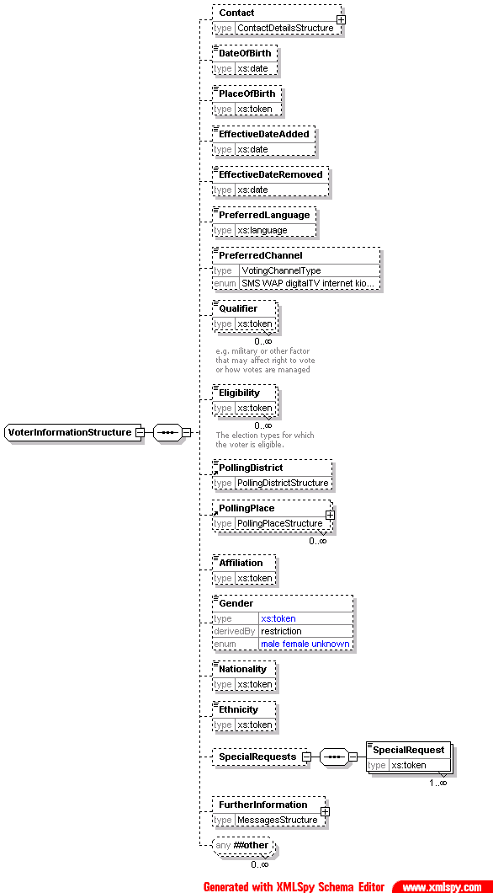This contains more information about the voter. It contains all the information that would typically be included on an electoral roll other than that used for identification of the voter. In many cases, it will be restricted to only include the information required in a specific message type.
The Qualifier element is used to hold information that might affect a voter's right to vote or how their votes are managed. Suitable enumerations for this are likely to be added as part of localisation. The eligibility indicates what election types a voter is eligible to participate in.
Special requests are requests from the voter, for example, for wheelchair access to a polling station.

UK Specifics
The specifics listed here are applicable to uses of this type.
Error Code | Error Description
4xxx-101 | Affiliation is not used
4xxx-102 | PlaceOfBirth is not used
4xxx-103 | Eligibility is not used
4xxx-104 | Gender is not used
4xxx-105 | Nationality, if used, must be 'G' or 'K'
4xxx-106 | Ethnicity is not used
4xxx-107 | Qualifier is not used (310, 330 only)
4120-107 | This value for Qualifier is not allowed (120 only)

VToken & VTokenQualified

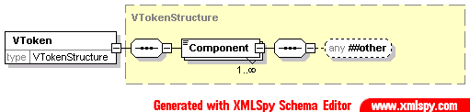The voting token contains the information required to authenticate the voter’s right to vote in a specific election or contest. A voting token can consist of a continuous string of encoded or encrypted data, alternatively it may be constructed from several data components that a user may input at various stages during the voting process (such as PIN, password and other coded data elements). The totality of the voting token data proves that a person with the right to vote in the specific election has cast the vote.
Depending on the type of election, the voter may need to cast their votes anonymously, thus not providing a link to the voter’s true identity. In this case the voting token data will not identify the actual person casting the vote; it just proves that the vote was cast by a person with the right to do so. Election rules may require a link to be maintained between a vote and a voter, in which case a link is maintained between the voting token data and the voter’s identity.
The components of the voting token are identified by a Type attribute and may contain text or markup from any namespace depending on the token type. The content could be defined further in separate schemas for specific types of token.

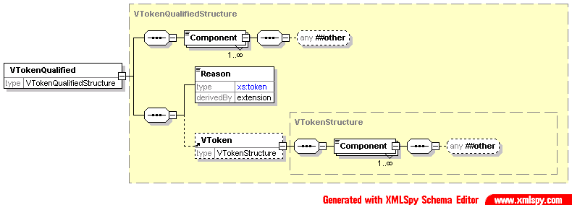There are occasions when a normal voting token cannot be used. For example, if a voter is challenged, or an election officer claims the voter has already voted. In these circumstances a qualified voting token can be used and treated appropriately by the election system according to the election rules. For example, challenged votes might be ignored unless there were sufficient to alter the result of the election, in which case each vote would be investigated and counted if deemed correct to do so.
The VTokenQualifiedStructure is therefore an extension of the VTokenStructure to add the additional information required. This additional information comprises a reason for qualification (as a Reason element with a Type attribute and textual description) and possibly an original VToken.

110 - Election Event

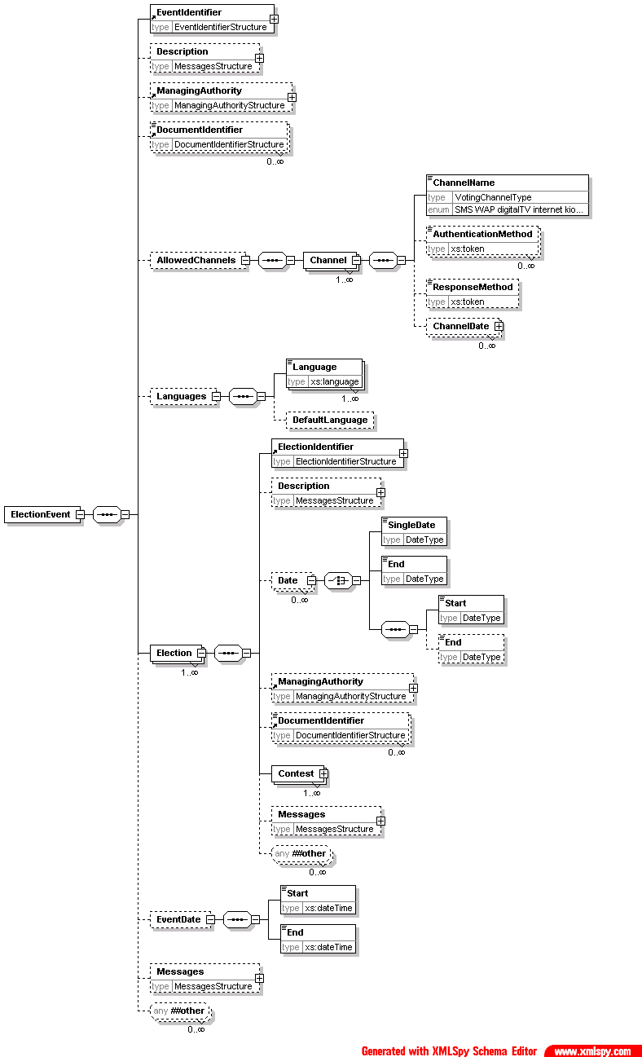
The Contest element is expanded in the next diagram
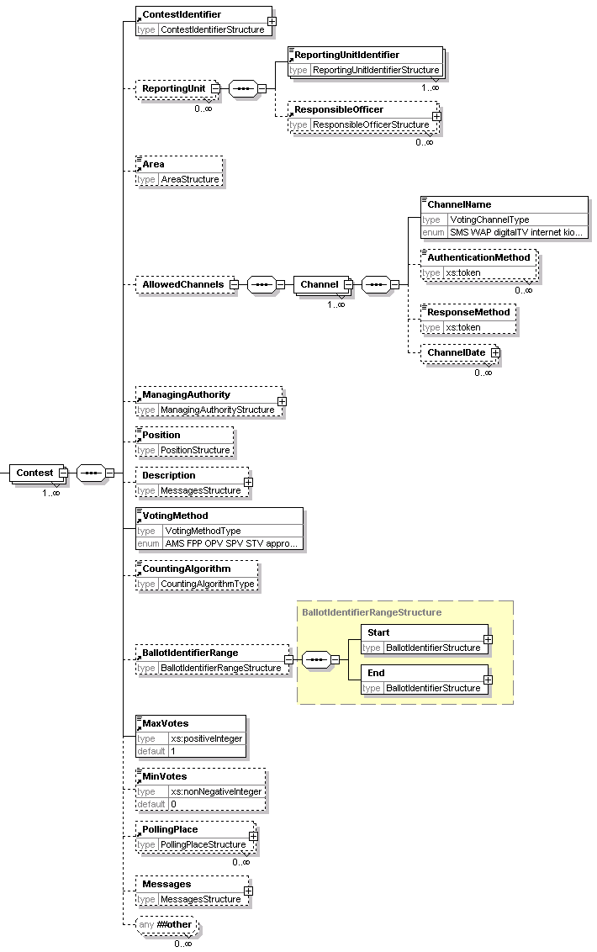

Description of Schema
This schema is used for messages providing information about an election or set of elections. It is usually used to communicate information from the election organisers to those providing the election service.
The message therefore provides information about the election event, all elections within that event and all contests for each election.
For the election event, the information includes the ID and name of the event, possibly with a qualifier on the event. This qualifier is used when an event has several local organisers. For example, for a UK general election, each constituency organises its own contests. The election event is therefore the general election, whilst the qualifier would indicate the constituency. Other information regarding an election event comprises the languages to be used, the start and end dates of the event, potentially a list of external documents that are applicable (such as the rules governing the election), a description and information about the managing authority.
The managing authority can be indicated for the event, each election, each contest within the election and each reporting unit.
An election can have a number of dates associated with it. For example, there is likely to be a period allowed for nomination of candidates and a date when the list of eligible voters is fixed. Each date can be expressed as a single date when something happens, a start date, an end date, or both start and end dates. These dates can be either just a date or both a date and time using the subset of the ISO 8601 format supported by XML Schema.
Like the event, an election can have both a managing authority and referenced documents. Finally, there is a Messages element for additional information.
A contest has a name and ID. It can also have reporting unit identifiers. A contest may need to specify its geographical area independently from its name, for which purpose the Area element is provided. Each contest can specify the voting channels allowed. In general, the list of possible channels will be further restricted as part of a local customisation. Each channel can specify several methods for authenticating the voter, such as PIN and password, and a response method, indicating the type of response to be given to a cast vote. Finally, facilities are provided to indicate the dates and times when the channel will be available to the voter.
As described previously, a contest can indicate its managing authority. It may also indicate the position (such as ‘President’) for which votes are being cast. The Description allows for additional text describing the contest. Each contest indicates the voting method being used, whilst the CountingAlgorithm indicates the method of counting (such as the d'Hondt or Meeks method) that will be used. The minimum and maximum number of votes to be cast by each voter can also be indicated.
A list of polling places can be provided. These can be either physical locations for people to go to vote (or for postal votes) or electronic locations. An ‘other location’ is also allowed for cases where these do not meet the requirements. A location can also say when it will be available. This is intended for mobile polling stations that will only be available at a given address for a part of the voting period.
Finally, a Messages element allows for additional information that might be communicated to the voter later through other messages.

EML Schematron Rules

Rule ID | Schematron Rule
3110-001 | The allowed channels can be declared at the Event or Contest level, but not both.

Description of UK Specifics
Error Code | Error Description
4110-101 | ElectionGroup is not used in the London Mayoral election.
4110-102 | Position must have the value ‘Mayor’ in the London Mayoral election
4110-103 | VotingMethod must have the value ‘supplementaryvote’ in the London Mayoral election
4110-104 | CountingAlgorithm is not used in the London Mayoral election.
4110-201 | ElectionGroup must have the value ‘London Assembly’ in the London Assembly London-wide election
4110-202 | Position must have the value ‘Member of the London Assembly’ in the London Assembly London-wide election
4110-203 | VotingMethod must have the value ‘AMS’ in the London Assembly London-wide election
4110-204 | CountingAlgorithm must have the value ‘modified d'Hondt’ in the London Assembly London-wide election
4110-301 | ElectionGroup must have the value ‘London Assembly’ in the London Assembly constituency election
4110-302 | Position must have the value ‘Member of the London Assembly’ in the London Assembly constituency election
4110-303 | VotingMethod must have the value ‘’FPP’ in the London Assembly constituency election
4110-304 | CountingAlgorithm is not used in the London Assembly constituency election.
4110-401 | ElectionGroup is not used in the European Parliamentary election.
4110-402 | Position must have the value ‘MEP’ in the European Parliamentary election
4110-403 | VotingMethod must have the value ‘partylist’ in the European Parliamentary election
4110-404 | CountingAlgorithm must have the value ‘d'Hondt’ in the European Parliamentary election
4110-501 | ElectionGroup is not used in a local authority election in England and Wales.
4110-502 | ReportingUnit is not used in a local authority election in England and Wales.
4110-503 | A contest must indicate the position being contested in a local authority election in England and Wales
4110-504 | VotingMethod must the value ‘FPP’ in a local authority election in England and Wales
4110-505 | CountingAlgorithm is not used in a local authority election in England and Wales.
There are several possible dates associated with an election. These are identified using the Date element with its Type attribute. Each date can have a start date, an end date, both or a single date. Where the date types below are used, the Type attribute should use the exact spelling shown.

Type | Elements Used
Notice of Election | End
Delivery of nomination papers | Start, End
Statement of persons nominated | SingleDate
Notice of appointment of election agents | End
Withdrawal of candidature | End
Change to postal vote records | End
Issue of postal ballots | Start, End
Notice of Poll | SingleDate
Notice of appointment of counting agents | End
Notice of appointment of polling agents | End
Corrections to register | End
Requests to replace lost postal ballots | Start, End
Opening of postal votes | SingleDate
Receipt of expenses | End

120 - Inter Database

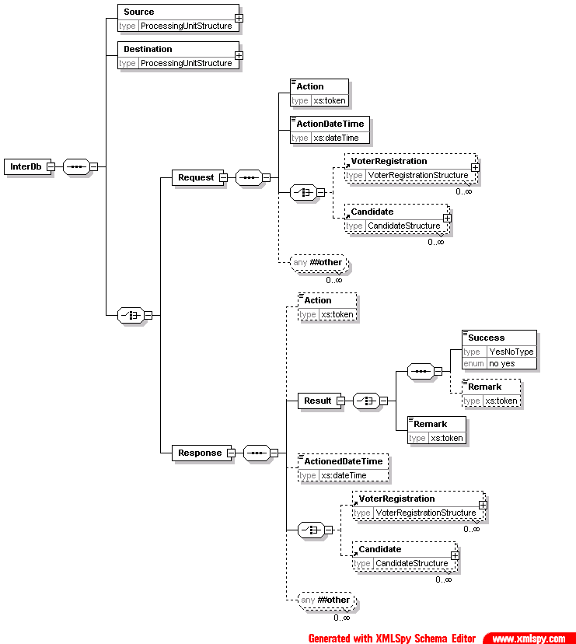
Description of Schema
This schema is used for messages requesting services from other electoral list or candidate databases. This can, for example, be used to de-dupe databases or check that a candidate in an election is only standing in one contest. The schema is in two parts, so a message will be either a request or a response.
Both request and response start by identifying the source and destination as processing units.
A request has an Action code to identify the request being made. The ActionDateTime is used to specify when the action should be carried out, and then there is an optional list of voters or candidates.
A response has a similar structure. It could be that the Action code is no longer required, so this is now optional. The TransactionID must match that given in the request. The Result is either a binary Success flag or a remark or both. Again, there is a date and time, but in this case it is the date and time at which the action took place.

Description of UK Specifics
The allowed values for Qualifier are: 'crown servant', 'EU servant', 'lord', '69/70' or 'overseas'
Error Code | Error Description
4120-101 | Affiliation is not used
4120-102 | PlaceOfBirth is not used
4120-103 | Eligibility is not used
4120-104 | Gender is not used
4120-105 | Nationality, if used, must be 'G' or 'K'
4120-106 | Ethnicity is not used
4120-107 | This value for Qualifier is not allowed

130 - Response
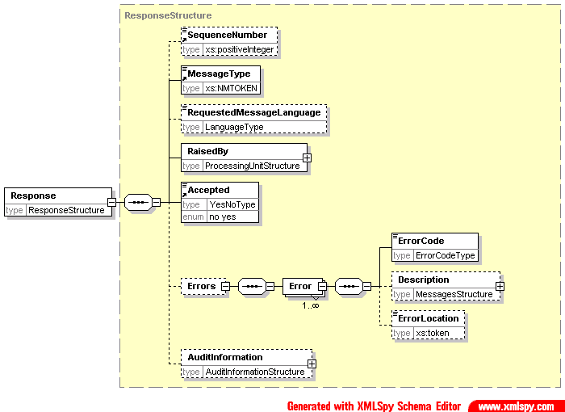

Description of Schema
Some messages have a defined response message that provides useful information. However, there is a need for a more general response, either to indicate that a message has been accepted, or to indicate the reasons for rejection.
The message includes information to identify the message to which the response applies (by using the same transaction id in the EML element and, if necessary, including the sequence number of the message to which the response applies in the Response element), with information on the entity raising the message, whether the message was accepted and information about the errors if it was not. The desired language for a display message can also be included to allow a downstream processor to substitute a language-specific error message if required.
If the message is reporting an error, the location of the error within the message can be indicated. Usually, this will be an XPath to the location of the error. However, errors detected by an XML parser may be in a different format, such as a line number.
Note that a single response can be raised for a series of sub-messages with the same transaction ID. This allows indication, for example, that a sub-message was missing.

Description of UK Specifics
Error Code | Error Description
3130-001 | If the message is not accepted, there must be an Errors element

210 - Candidate Nomination

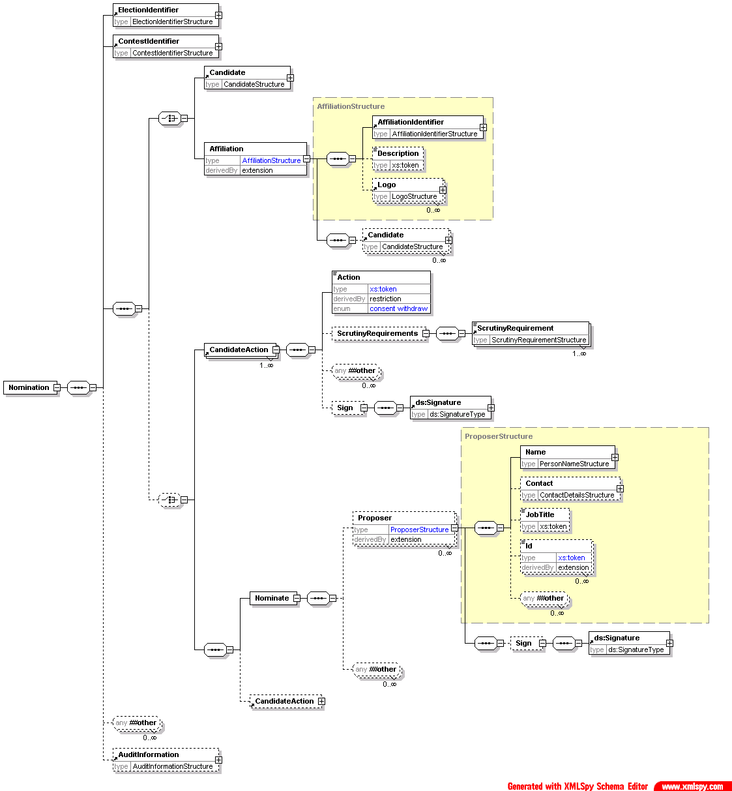

Description of Schema
Messages conforming to this schema are used for four purposes:
- nominating candidates in an election;
- nominating parties in an election;
- consenting to be nominated; or
- withdrawing a nomination.
Candidate consent can be combined in a single message with a nomination of the candidate or party or sent separately.
Note that the message does not cover nomination for referendums.
The election and contest must be specified. When a candidate is being nominated, there must be information about the candidate and one or more proposers. The candidate must supply a name. Optionally, the candidate can provide contact information, an affiliation (e.g. a political party) and textual profiles and election statements. These two items use the MessagesStructure to allow text in multiple languages. There is also scope to add additional information defined by the election organiser.
The proposers use the standard proposer declaration with a mandatory name and optional contact information and job title. Again, additional information can be required.
If a party is being nominated, the primary proposer will be the contact. Information on candidates in a party list can also be provided.
Candidates, either individuals or on a party list, must define the action being taken and provide scrutiny information. The scrutiny requirements indicate how the candidate has met any conditions for standing in this election. This could include indicating that a deposit has been paid or providing a reference to prove that he or she lives in the appropriate area. This information can be signed independently of the complete message.

Description of UK Specifics
When a party is being nominated, the element Proposer with a Category attribute with value ‘primary’ is the Nominating Officer.
Error Code | Error Description
4210-001 | The candidate must have a QualifyingAddress
4210-002 | The candidate must have either an Affiliation or be declared independent
4210-003 | If nominating an affiliation, the candidate should only have an identifier and full name
4210-004 | The affiliation (party) description is mandatory
4210-005 | An affiliation (party) logo is mandatory
4210-006 | Each proposer must have a contact method
4210-007 | The proposer must have an electoral roll number
4210-008 | If the candidate action is 'consent', the candidate must indicate whether they have paid their deposit

220 - Response to Nomination

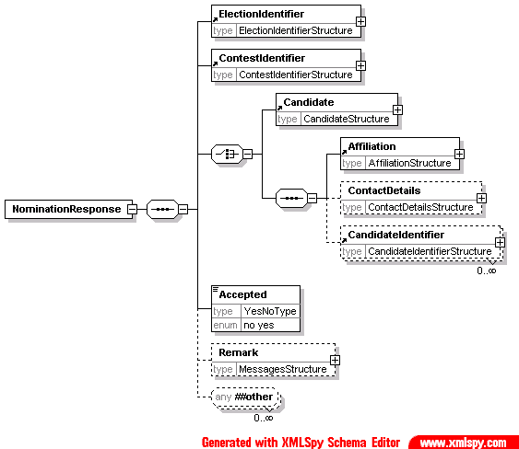

Description of Schema
This message is sent from the election organiser to the candidate or nomination authority for a party to say whether the nomination has been accepted. Along with the acceptance information and the basic information of election, contest and party and candidate names, the candidate's contact details and affiliation can be included and a remark explaining the decision.

EML Schematron Rules
Error Code | Error Description
3220-001 | If the nomination has not been accepted, a reason for rejection is required in the Remark element

230 - Candidate List

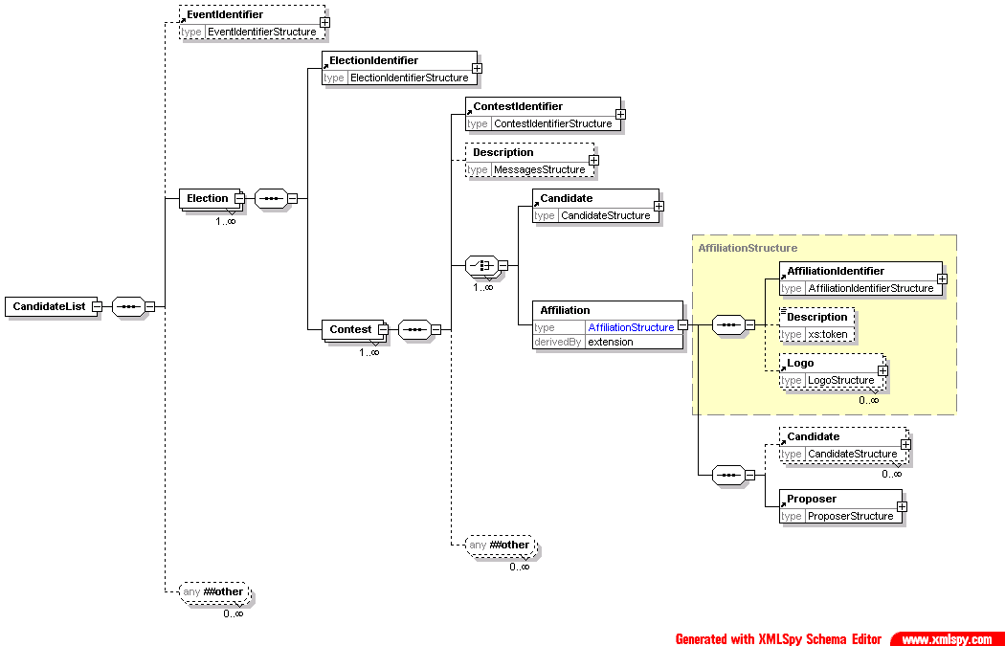

Description of Schema
This schema is used for messages transferring candidate lists for specified contests. It has the election event, election and contest identifiers, and optionally a contest description. The list itself can be either a list of candidates, each with a name, address, optional affiliation and other useful data, or a list of parties. In the latter case, contact information and a list of candidates under a party list system can also be included.

Description of UK Specifics
Error Code | Error Description
4230-001 | There must be an EventIdentifier element
4230-002 | Each candidate must have a QualifyingAddress
4230-003 | Each candidate must have either an Affiliation or be declared independent
4230-004 | The affiliation (party) description is mandatory
4230-005 | An affiliation (party) logo is mandatory
4230-006 | If nominating an affiliation, the candidate should only have an identifier and full name

310 - Voter Registration

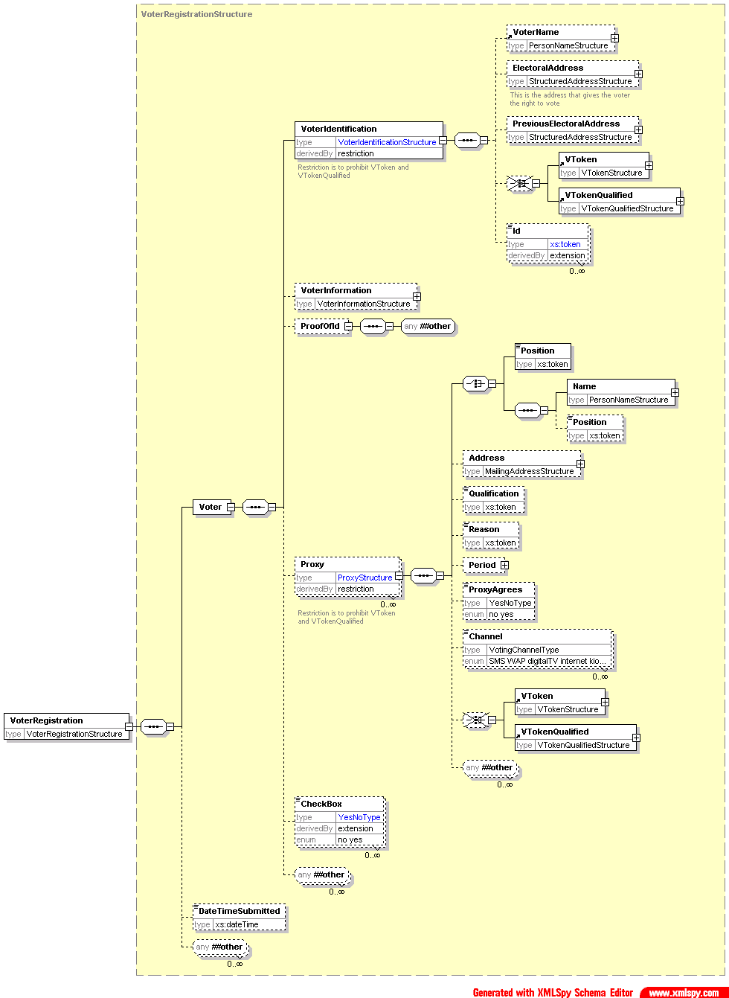

Description of Schema
This schema is used for messages registering voters. It uses the VoterIdentificationStructure, with the exception that no VToken or VTokenQualified is allowed. The VoterInformationStructure is used unchanged. Proof of ID can be provided, as can information about one or proxies, again without a voting token. The CheckBox element with its Type attribute allows binary information such as whether the voter's entry on the electoral register can be sold, or whether the voter wants to participate in the count.
There is the facility for the transmission channel (for example a trusted web site) to add the time of transmission.

Description of UK Specifics
Error Code | Error Description
4310-101 | Affiliation is not used
4310-102 | PlaceOfBirth is not used
4310-103 | Eligibility is not used
4310-104 | Gender is not used
4xxx-105 | Nationality, if used, must be 'G' or 'K'.
4310-106 | Ethnicity is not used
4310-107 | Qualifier is not used
4310-006 | There must be a CheckBox with a type of ‘include in sale of electoral roll’
4310-003 | VoterName is mandatory
4310-004 | ElectoralAddress is mandatory

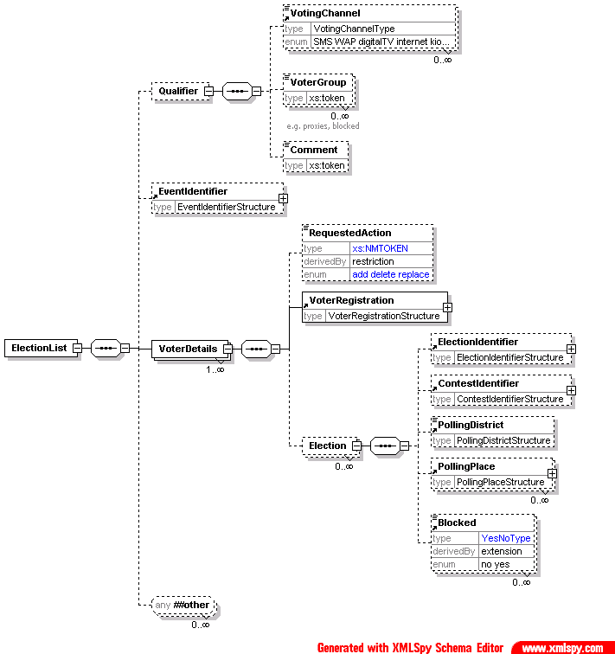
330 - Election List

Description of Schema
This schema is used for messages communicating the list of eligible voters for an election or set of elections. Partial lists are allowed through the use of the Qualifier, Blocked and VoterGroup elements. So, for example, a list of postal voters or a list of proxies can be produced.
For each voter, information is provided about the voter himself or herself, and about the elections and contests in which the voter can participate. The information about the voter is the same as that defined in the 310-voterregistration schema. Added to this can be a list of elections, each identifying the election and the contest in which this voter is eligible to vote, and the polling places available. Any voter can have a Blocked element set against them with an optional Reason and Channel. This allows a list to be produced for a polling place indicating those that have already voted by another means or who have registered for a postal vote. It can also be used if the complete electoral register must be transmitted (perhaps as a fraud prevention measure) but some people on the register are no longer eligible to vote.

EML Schematron Rules
Error Code | Error Description
3330-001 | The sequenced element name is incorrect
3330-002 | The polling district can only be included for either the voter or the election.
3330-003 | The polling place can only be included for either the voter or the election.

EML-UK Explanation and Rules
Error Code | Error Description
4330-001 | VoterName must be present
4330-002 | The voter must have an electoral address
4330-003 | The Id element of Voter must be present and have the Type ‘electoral roll number’
4330-101 | Affiliation is not used
4330-102 | PlaceOfBirth is not used
4330-103 | Eligibility is not used
4330-104 | Gender is not used
4xxx-105 | Nationality, if used, must be 'G' or 'K'
4330-106 | Ethnicity is not used
4330-107 | Qualifier is not used
4330-011 | VoterDetails must have at least one Election child
4330-012 | ElectionIdentifier must be present
4330-013 | ContestIdentifier must be present
4330-014 | PollingDistrict must be present
3330-015 | The Reason attribute is mandatory if Blocked='yes'

340 - Polling Information
The Election element is expanded in the next diagram
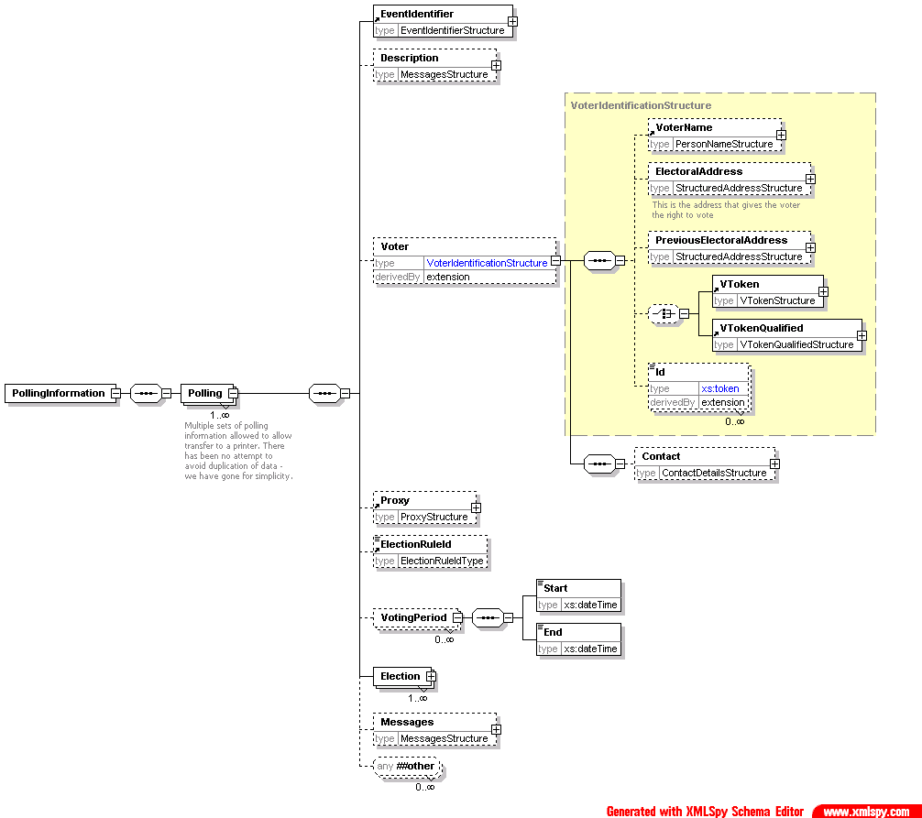
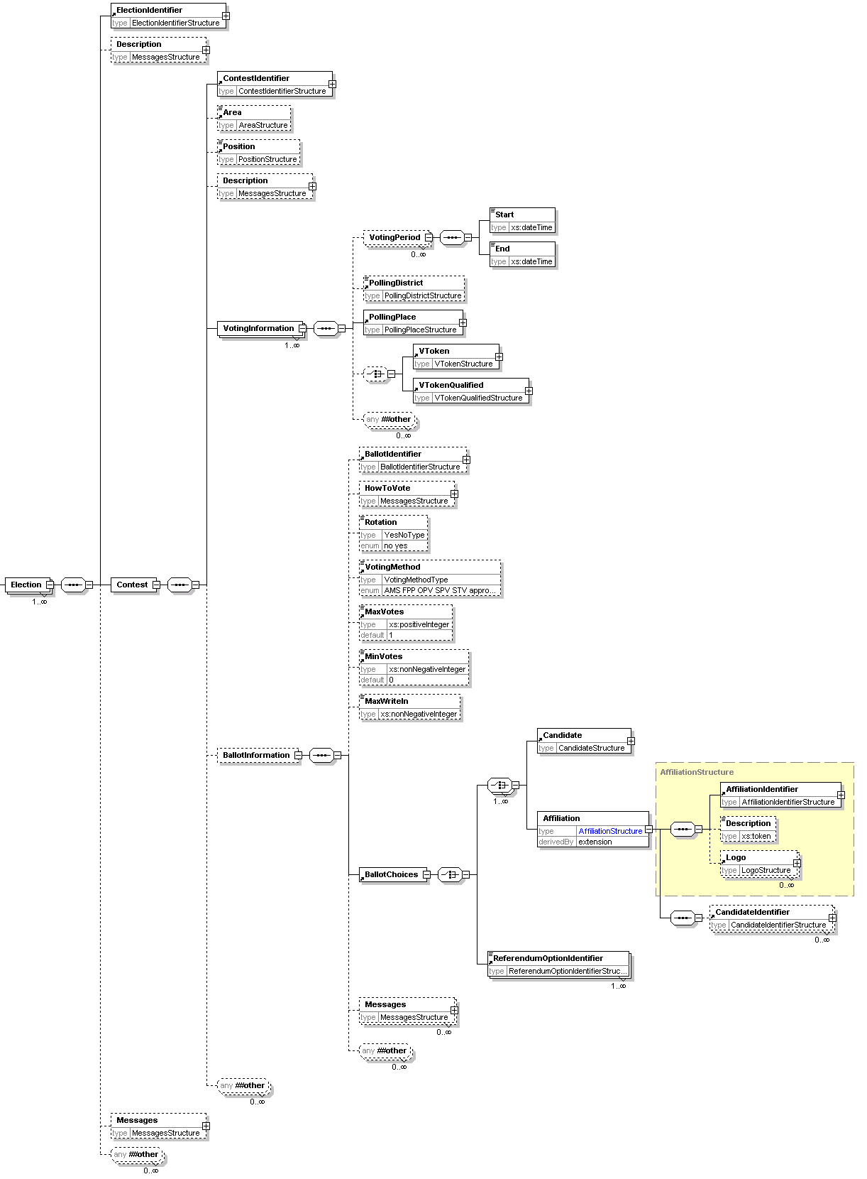

Description of Schema
The polling information message defined by this schema is sent to a voter to provide details of how to vote. It can also be sent to a distributor, so multiple sets of information are allowed. In the case of SMS voting, ballot information may also be required, so this can be included. Either one or several sets of polling information may be sent to each voter for any election event.
Some information about the voter and any proxy may be included, for example to print on a polling card. This can also include a mailing address for a distributor to use.
Information about the elections and contests is included for the benefit of the voter. For each voting channel, this includes where to vote (which could be a polling station, URL for Internet voting, phone number for SMS voting etc) and the times that votes can be placed. Use of the DisplayOrder attribute on these allows the display or printing of information to be tailored from within the XML message.
Ballot information may be included if required. This is a subset of the information defined in the 410-ballots schema. In this case, it is likely that the short code for a candidate will be used for SMS voting. It is possible that an expected response code will be provided as well. Both the short code and expected response code may be tailored to the individual voter as part of a security mechanism.

Description of UK Specifics
Error Code | Error Description
3340-001 | The voter's name is mandatory
3340-002 | The voter's Id is mandatory and must be an electoral roll number
3340-003 | The voter's mailing address is mandatory
3340-004 | The candidate's date of birth should not be included
3340-005 | The candidate's age should not be included
3340-006 | The candidate's gender should not be included
3340-007 | The candidate's qualifying address should not be included
3340-008 | The candidate's contact information should not be included
3340-009 | The candidate's profession should not be included
3340-010 | Information about the candidate's agent should not be included
3340-011 | The candidate's profile should not be included
3340-012 | The candidate's election statement should not be included
3340-013 | If there is a voting token or qualified voting token at the voter level, there should not be one at the voting information level

350a - Outgoing Generic
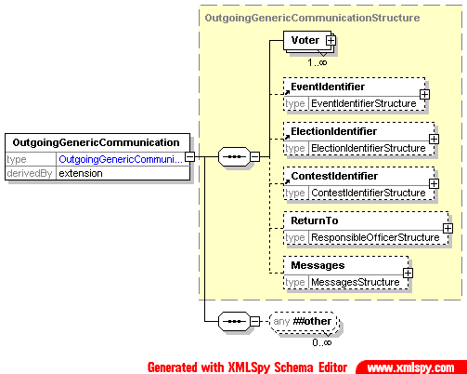

Description of Schema
This schema provides a common structure for communications to the voter. Individual message types can be designed based on extensions of this schema.
The voter must always provide a name and might provide one or more identifiers. These are shown as a restriction of the VoterIdentificationStructure. Contact details are also required, and it is expected that at least one of the allowed contact methods will be included. Inclusion of proxy information is optional.
The identifiers for the election event, election and contest are optional. There is then an element in which a message can be placed in any of several different formats according to the channel being used.

Description of UK Specifics
None identified.

350b - Incoming Generic
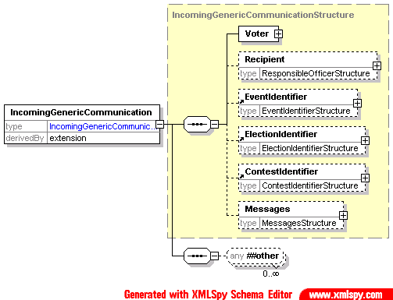

Description of Schema
This schema provides a common structure for communications from the voter. Individual message types can be designed based on extensions of this schema.
The voter's name must be provided and there can be one or more identifiers. These are shown as a restriction of the VoterIdentificationStructure. Contact details are also required, and it is expected that at least one of the allowed contact methods will be included. Inclusion of proxy information is optional.
The identifiers for the election event, election and contest are optional. There is then an element in which a message can be placed in any of several different formats according to the channel being used.

Description of UK Specifics
None identified.

350c - Internal Generic
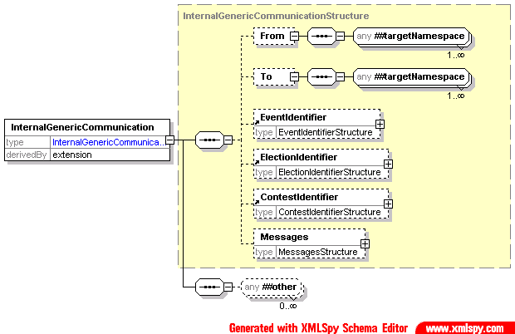

Description of Schema
This schema provides a common structure for communications between those involved in organizing an election. Individual message types can be designed based on extensions of this schema.
There are optional To and From elements, which can contain any EML elements. It is expected that these will usually be a responsible officer or a person's name and contact information.
The identifiers for the election event, election and contest are optional. There is then an element in which a message can be placed in any of several different formats according to the channel being used.

Description of UK Specifics
None identified.

360a - Outgoing Channel Options
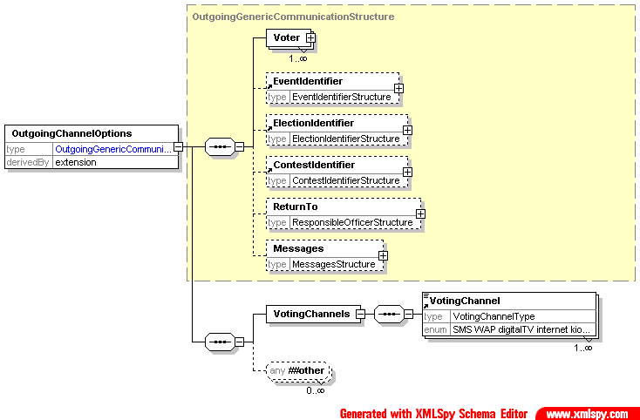

Description of Schema
This schema is used for messages offering a set of voting channels to the voter. It is an extension of schema 350a. A message conforming to this schema will include a list of allowed channels for a specific election event or election within the event.

Description of UK Specifics
None identified.

360b - Incoming Channel Options
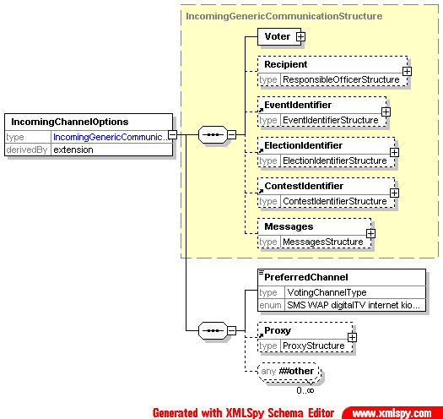

Description of Schema
This schema is used for messages indicating a preferred channel. It may be sent in response to 360a or as an unsolicited message if this is supported within the relevant jurisdiction.
It is an extension of schema 350b, and indicates a single preferred voting channel.

Description of UK Specifics
None identified.

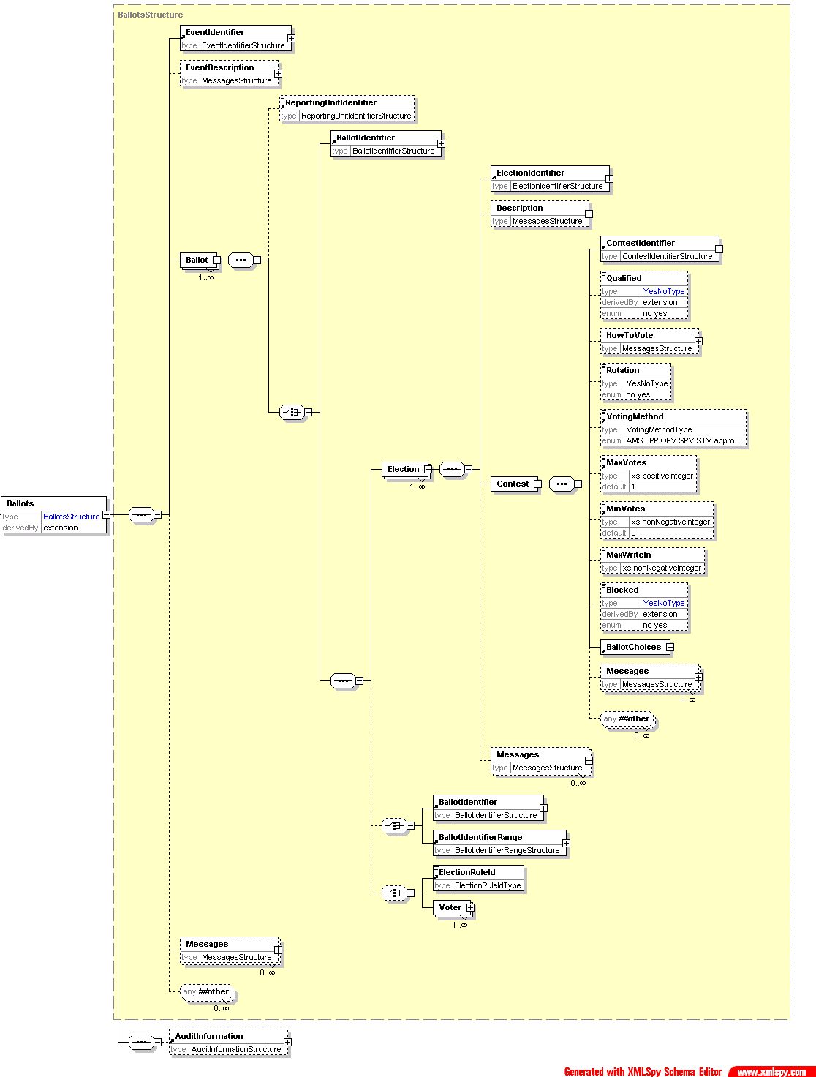
410 - Ballots
The Voter element is
expanded below
The BallotChoices element
is expanded below
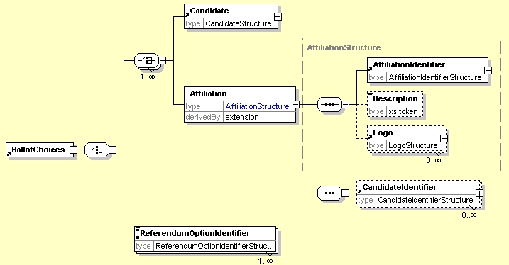

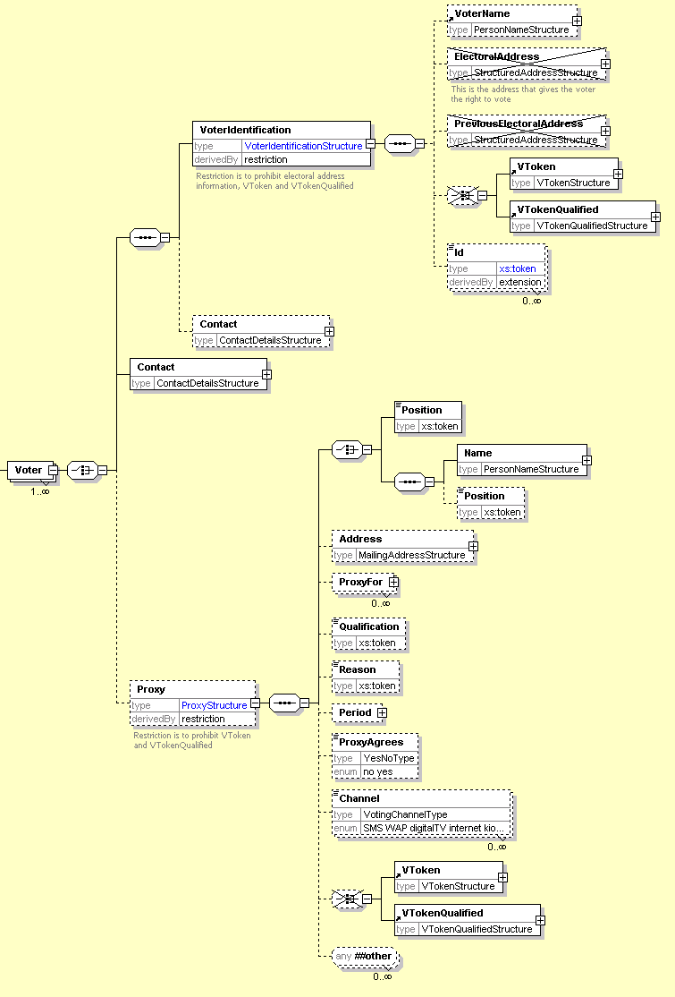

Description of Schema
This schema is used for messages presenting the ballot to the voter or providing a distributor with the information required to print or display multiple ballots.
In the simplest case, a distributor can be sent information about the election event and a ballot ID to indicate the ballot to print.
In other cases, the full information about the elections will be sent with either an election rule ID to identify the voters to whom that election applies or a set of voter names and contact information. If the ballot is being sent directly to the voter, this information is not required. Since ballot papers are likely to require a unique identifier printed on them, the range to be used for each ballot type can be defined.
The election information starts with the election identifier and description. This is followed by information related to the contest and any other messages and information required. Note that each voter can only vote in a single contest per election, so only a single iteration of the Contest element is required.
A contest must have its identifier and a list of choices for which the voter can vote. A voter can vote for a candidate, an affiliation (possibly with a list of candidates) or a referendum proposal. There is also a set of optional information that will be required in some circumstances. Some of this is for display to the voter (HowToVote and Messages) and some controls the ballot and voting process (Rotation, VotingMethod, MaxVotes, MinVotes, MaxWriteIn).

Description of UK Specifics

Error Code | Error Description
4410-001 | The element MaxWriteIn must not be used
4410-002 | The element MaxVotes is mandatory
4410-003 | The element HowToVote is mandatory
4410-004 | The affiliation must have a logo
4410-005 | The element VoterName is mandatory in a VoterIdentification
4410-006 | The proxy must have a name
4410-007 | The proxy must have an address
4410-008 | The proxy must identify who he/she is a proxy for
4410-009 | The candidate's date of birth must not be given
4410-010 | The candidate's age must not be given
4410-011 | The candidate's gender must not be given
4410-012 | The candidate's contact information must not be given
4410-013 | The candidate's profession must not be given
4410-014 | The candidate's agent information must not be given
4410-015 | The candidate's profile must not be given
4410-016 | The candidate's election statement must not be given

420 - Authentication
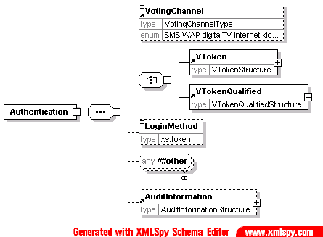

Description of Schema
The authentication message defined by this schema may be used to authenticate a user during the voting process. Depending on the type of election, a voter's authentication may be required; the precise mechanism used may be channel and implementation specific, and can be indicated using the LoginMethod element.. In some public elections the voter must be anonymous, in which case the prime method used for authentication is the voting token. The voting token can contain the information required to authenticate the voter's right to vote in a specific election or contest, without revealing the identity of the person voting. Either the VToken or the VTokenQualified must always be present in an authenticated message. The VotingChannel identifies the channel by which the voter has been authenticated.

Description of UK Specifics

None identified.

430 - Authentication Response
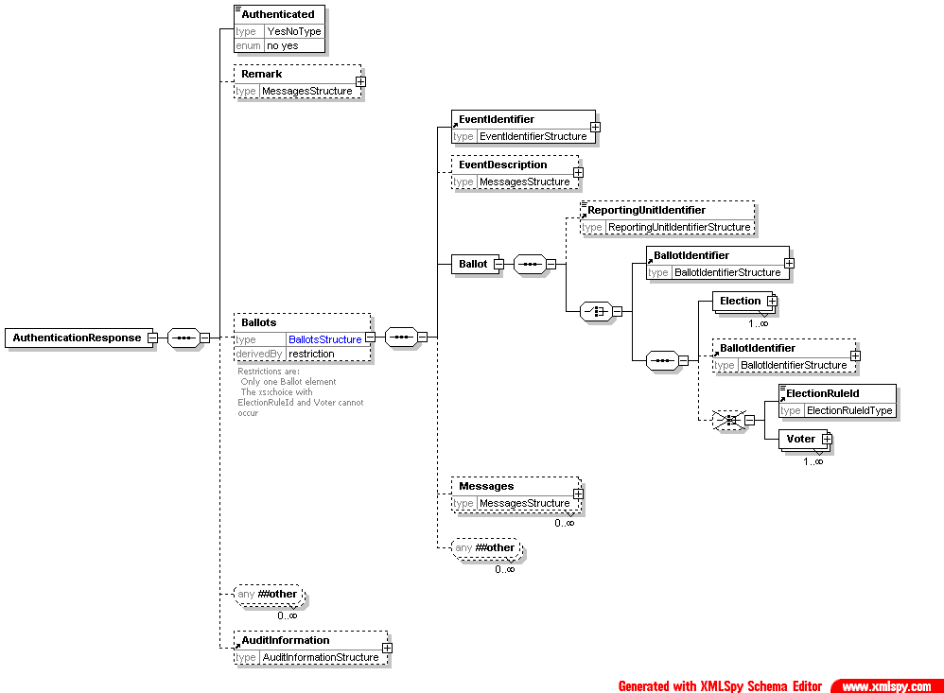

Description of Schema
The authentication response is a response to message 420. It indicates whether authentication succeeded using the Authenticated element, and might also present the ballot to the user. This is a restriction of the Ballots element to allow only a single ballot per reply.

Description of UK Specifics

Error Code | Error Description
4430-001 | The element MaxWriteIn must not be used
4430-002 | The element MaxVotes is mandatory
4430-003 | The element HowToVote is mandatory
4430-004 | The affiliation must have a logo
4430-006 | The proxy must have a name
4430-007 | The proxy must have an address
4430-008 | The proxy must identify who he/she is a proxy for
4430-009 | The candidate's date of birth must not be given
4430-010 | The candidate's age must not be given
4430-011 | The candidate's gender must not be given
4430-012 | The candidate's contact information must not be given
4430-013 | The candidate's profession must not be given
4430-014 | The candidate's agent information must not be given
4430-015 | The candidate's profile must not be given
4430-016 | The candidate's election statement must not be given
4430-017 | If the value of Authenticated is "no", the reason must be given

440 - Cast Vote
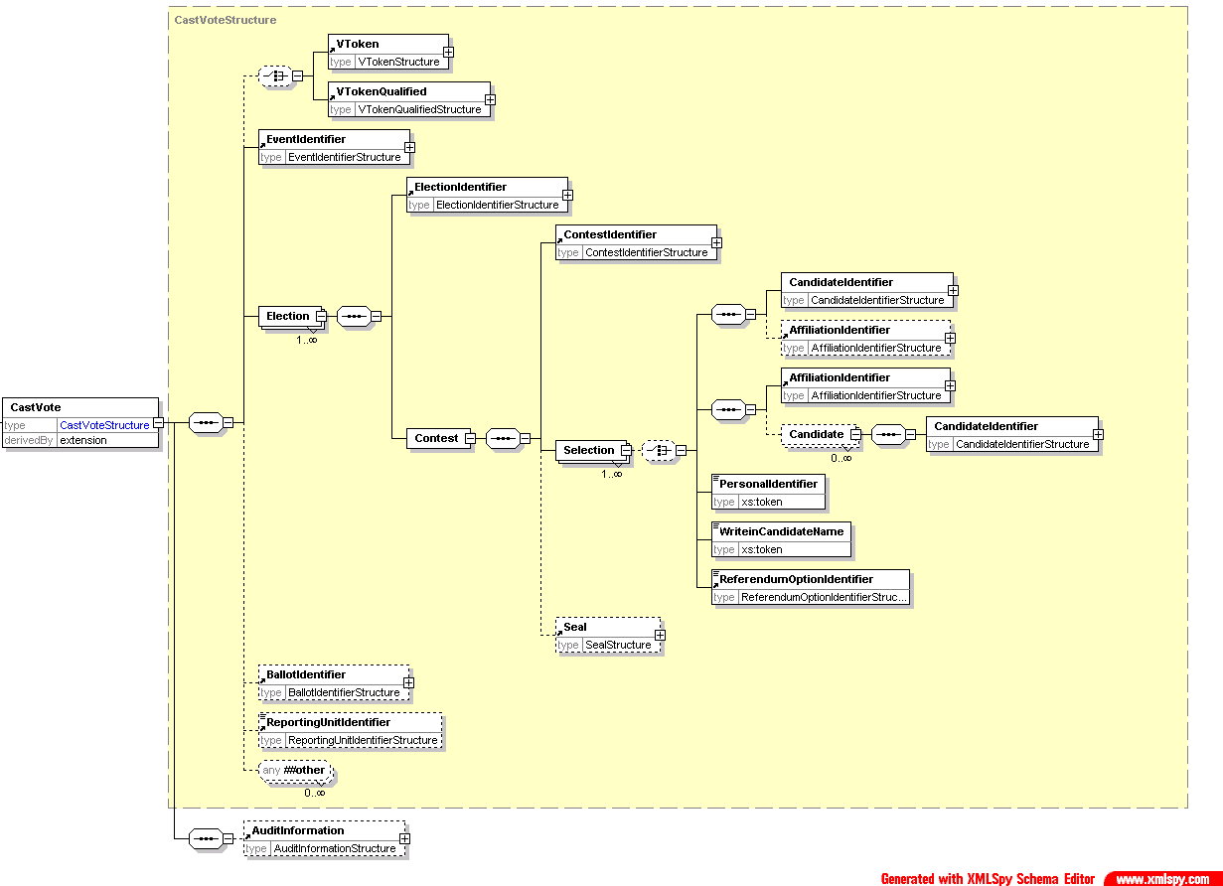

Description of Schema
This message represents a cast vote, which comprises an optional voting token (which may be qualified) to ensure that the vote is being cast by an authorized voter, information about the election event, each election within the event and the vote or votes being cast in each election, an optional reference to the ballot used, the identifier of the reporting unit if applicable and a set of optional audit information.
For each election, the contest is identified, with a set of, possibly sealed, votes. The votes are sealed at this level if there is a chance that the message will be divided, for example so that votes in different elections can be counted in different locations.
The selection of candidates, affiliations or a referendum option uses the Selection element. If an election requires preferences to be expressed between candidates, multiple Selection elements will be used, each of these having a suitable Value attribute. Some elections allow write-in candidates, and these are handled in a similar way. Preferences can also be expressed between parties, using the Affiliation element. The PersonalIdentifier is used in elections where each voter is given an individual list of codes to indicate their selection.
A more complex election might request the voter to vote for a party, then express a preferences of candidates within the party. In this case, the Affiliation element is used to indicate the party selected, and multiple CandidateIdentifier elements, each with a Value attribute are used to express candidate preferences.
Preferences in a referendum are handled in the same way as they are for candidates and parties, using the ReferendumOptionIdentifier.

Description of UK Specifics

Error Code | Error Description
4440-001 | Write in candidates are not allowed
4440-002 | If Selection has a ShortCode attribute, it should not have child elements
4440-003 | If there is no VToken or VTokenQualified, every Selection element must have a PersonalIdentifier child
4440-004 | VotingChannel is mandatory in the AuditInformation

445 - Retrieve Vote
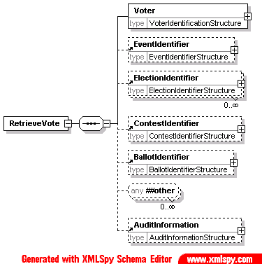

Description of Schema
This message is used for voting systems that include a pre-ballot box from which votes can be retrieved and amended before being counted. When a vote is retrieved, it should be deleted from the pre-ballot box.

Description of UK Specifics
This message type is not used in UK public elections.

450 - Vote Confirmation
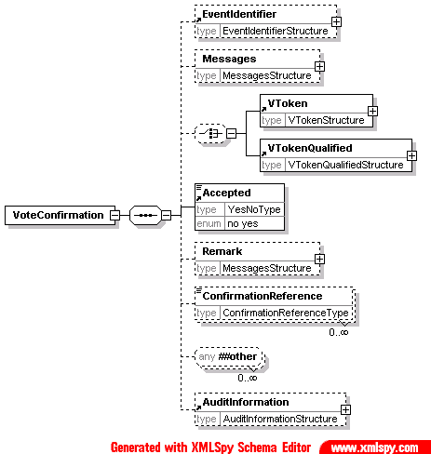

Description of Schema
The vote confirmation message can be used to show whether a vote has been accepted and provide a reference number in case of future queries. Some voting mechanisms require multiple ConfirmationReference elements. If the vote is rejected, the Remark element can be used to show a reason.

Description of UK Specifics

Error Code | Error Description
4450-001 | If the value of Authenticated is "no", the reason must be given

460 - Votes
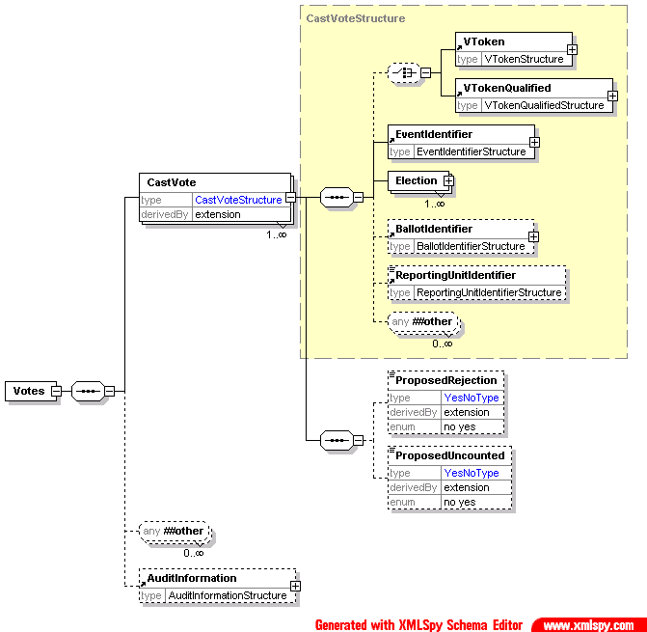
See 440-CastVote for the detail of the CastVoteStructure.

Description of Schema
This schema is used to define a message comprising a set of votes being transferred for counting. It is a set of CastVote elements from schema 440 with the addition of the ProposedRejection and ProposedUncounted elements and audit information for the voting system. A ProposedRejection or ProposedUncounted element must have a ReasonCode attribute, and may have a Reason attribute to describe the code. They may also have an Objection attribute. This indicates that someone has objected to this vote being rejected or the proposal that it should not be counted.

EML Schematron Rules

Error Code | Error Description
3460-001 | A vote cannot be proposed for both rejection and not being counted
3460-002 | The sequenced element name is incorrect

Description of UK Specifics

Error Code | Error Description
4460-002 | The reason code is not valid
4460-003 | The reason must be provided and be correct for this code
4460-004 | The reason must be provided and be correct for this code
4460-005 | The reason must be provided and be correct for this code
4460-006 | The reason must be provided and be correct for this code
4460-007 | The reason must be provided and be correct for this code

470 - VToken Log
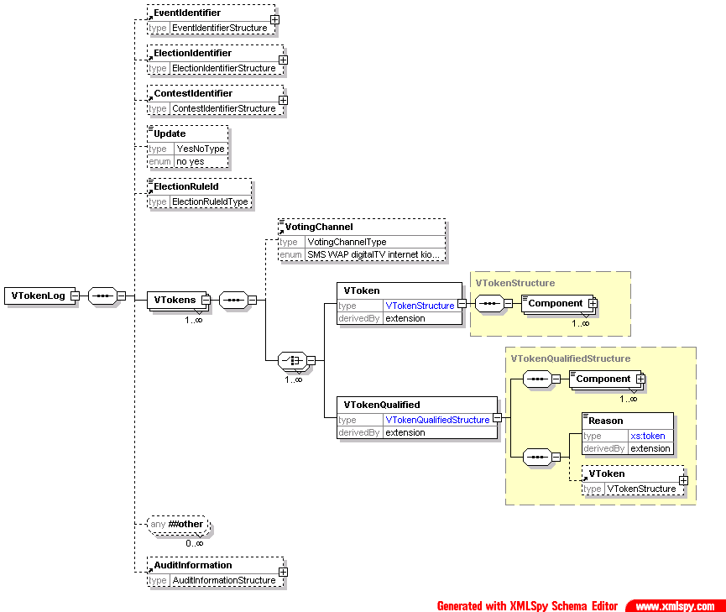

Description of Schema
The message defined by this schema is used to add voting tokens (which may be qualified) to an audit log. The VToken or VTokenQualified is extended by the addition of a Status attribute with a value of voted or unvoted. In addition to sending single tokens as they are used, the schema can be used to validate a message sending multiple tokens optionally grouped by voting channel. This might be used instead of sending tokens as they used or, for example, to send the unused tokens at the end of an election. The Update element can be used to indicate that an existing log is being updated rather than the message containing a complete new log. The logging system can also be identified for audit purposes.

EML Schematron Rules

Error Code | Error Description
3470-001 | The sequenced element name is incorrect

Description of UK Specifics

Error Code | Error Description
4470-001 | The election identifier is mandatory
4470-002 | The voting channel is mandatory

480 - Audit Log
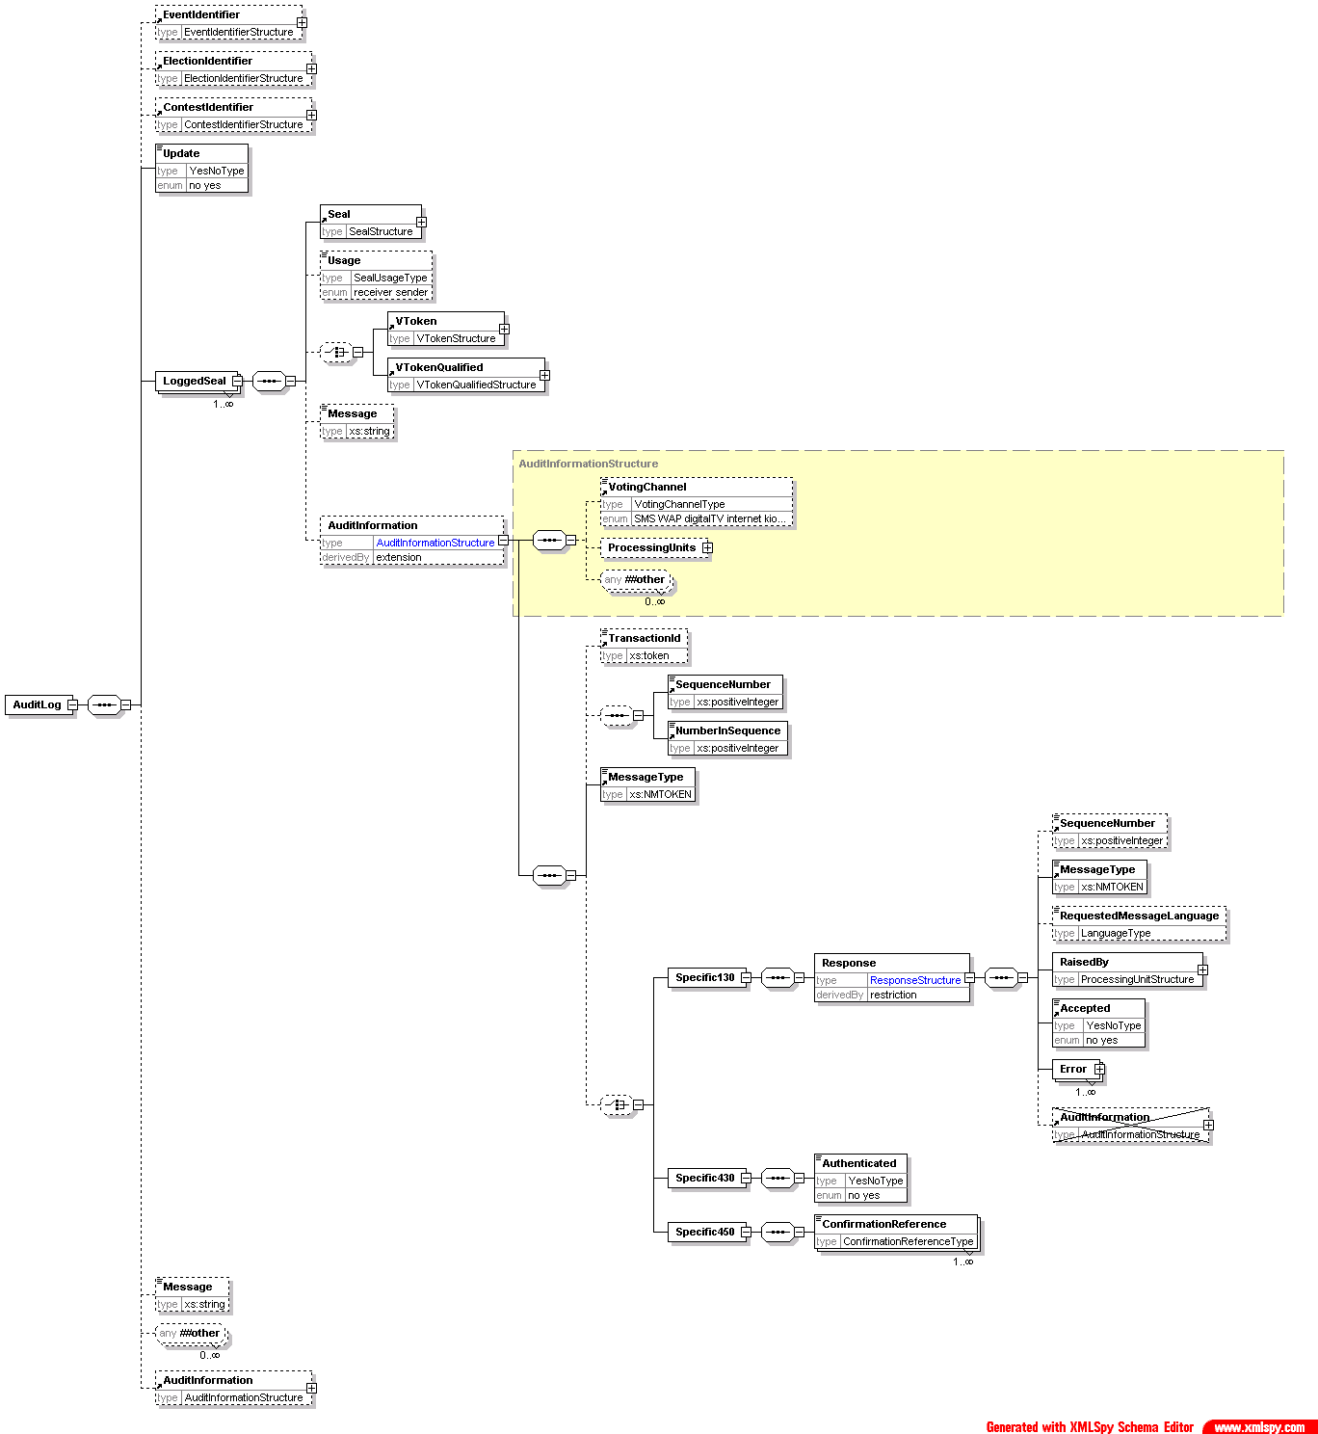

Description of Schema
The message defined by this schema is used to log the use of each seal with associated information for audit purposes.
An audit log message can be transmitted individually as the message causing the log entry is sent or received, or the logs can be stored, and several seals logged at once. Ideally, every device that can create or consume a message will create a log entry so that pairs of entries can be matched. The most important messages to log are those associated with the voting process itself, and these are shown below.

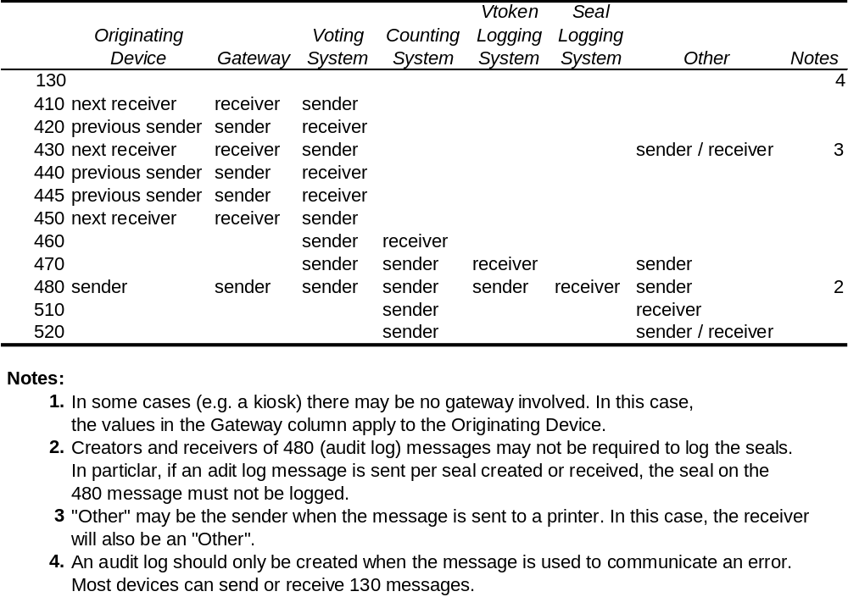
The message may contain the name and ID of the event, election and contest. It can also indicate whether this is an update to an existing log or a new log. Following the logged seals, a text message can be added as well as audit information for the audit logging message itself.
Each seal being logged must indicate whether the device sending the log was the sender or receiver of the sealed message. It may be accompanied by the voting token associated with the seal and possibly additional audit information. This will be the audit information from the message being logged with additional information about the message. Most of this is common to all message types, but some message types require specific audit information. One of these is the 130-response message. When this is used to convey an error, almost the complete message payload (the Response element and its contents apart from the audit information) is logged with the usual message-independent data.

Description of UK Specifics
As a minimum, the voting system will create a log entry for each of the messages which it either creates or consumes. It is a benefit if other devices can also create log entries.
Error Code | Error Description
4480-001 | A logged seal must have a Usage element
4480-002 | Message type 130 requires specific audit information
4480-003 | Message type 430 requires specific audit information
4480-004 | Message type 450 requires specific audit information

510 - Count
The VoteGroup group is
expanded below

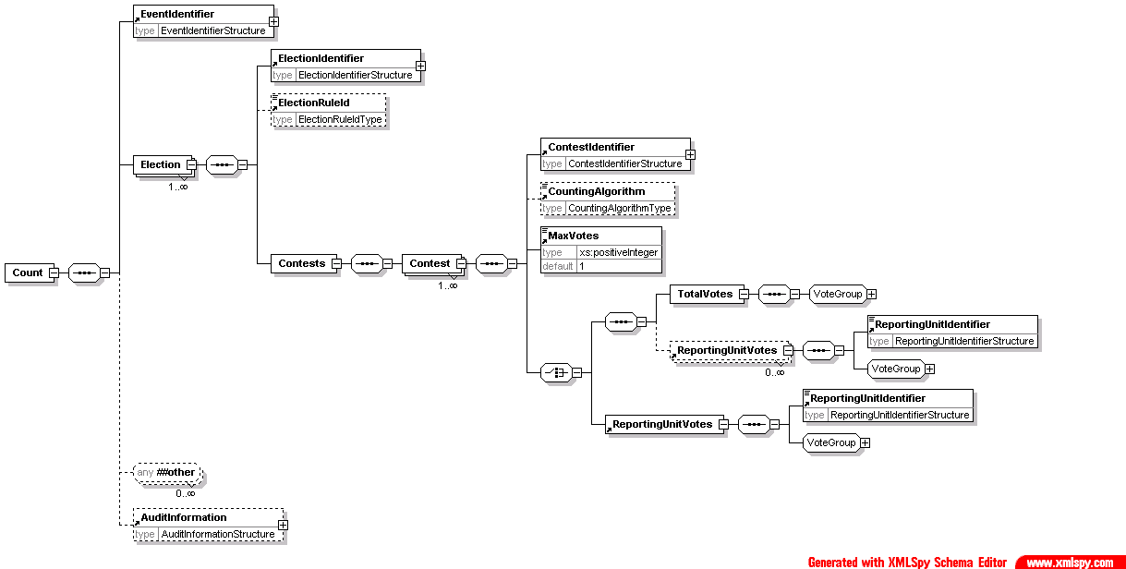
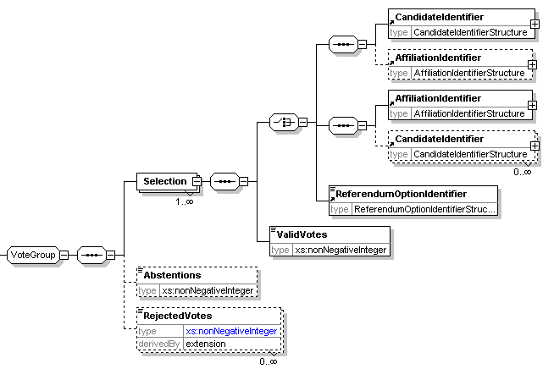

Description of Schema
The count message defined by this schema is used to communicate the results of one or more contests that make up one or more elections within an election event. It may also be used to communicate the count of a single reporting unit for amalgamation into a complete count.
The message includes the election event identifier, and for each election, the election identifier, an optional reference to the election rule being used and information concerning the set of contests.
In some cases, reporting for a contest may be required at a lower level (for example, for each county in a state). For this reason, reporting may be done at the level of the reporting unit, the total votes, or for a total vote and the breakdown according to the multiple reporting units.
Each contest indicates its identifier, and optionally the counting system and the maximum number of votes that each voter could cast. The key information is that about the votes cast for each option and the numbers of abstentions and rejected and uncounted votes. If a vote is rejected, for example, because a voter has chosen to spoil a ballot paper, many authorities will want to count that vote as having been cast. The UncountedVotes element is reserved for those cases where that record is not required, for example when the result is thought to be fraudulent. Both the UncountedVotes and RejectedVotes elements have Reason (optional) and ReasonCode (mandatory) attributes to indicate why the votes were treated as they have been. The former is a textual description, and the latter a code.
For each choice available to the voter, the identifier and number of valid votes are mandatory. The other information provided depends on the type of election. For example, the Value attribute of the Selection element can be used to indicate whether a candidate was a first or second choice in an election run under the single transferable vote system. In the simplest cases, the identifier for the candidate (perhaps with the party), the party or the referendum option are given. If the voter was able to vote for a party and provide a preference for candidates within the party, the AffiliationIdentifier element is used, and multiple CandidateIdentifier elements may be used, each with a Count attribute. This count is the result of whatever algorithm has been used to calculate the ranking of the candidates.

Description of UK Specifics
The following reasons and codes are allowed for rejecting a vote:
Code | Description
1 | Want of official mark
2 | Voting for more candidates than entitled to
3 | Writing or mark by which voter could be identified
4 | Unmarked or void for uncertainty
5 | Rejected in part

These are the UK -specific error messages:
Error Code | Error Description
4510-001 | Abstentions are not allowed - they should be treated as rejected votes
4510-002 | The reason code is not valid
4510-003 | The reason must be provided and be correct for this code
4510-004 | The reason must be provided and be correct for this code
4510-005 | The reason must be provided and be correct for this code
4510-006 | The reason must be provided and be correct for this code
4510-007 | The reason must be provided and be correct for this code

520 - Result
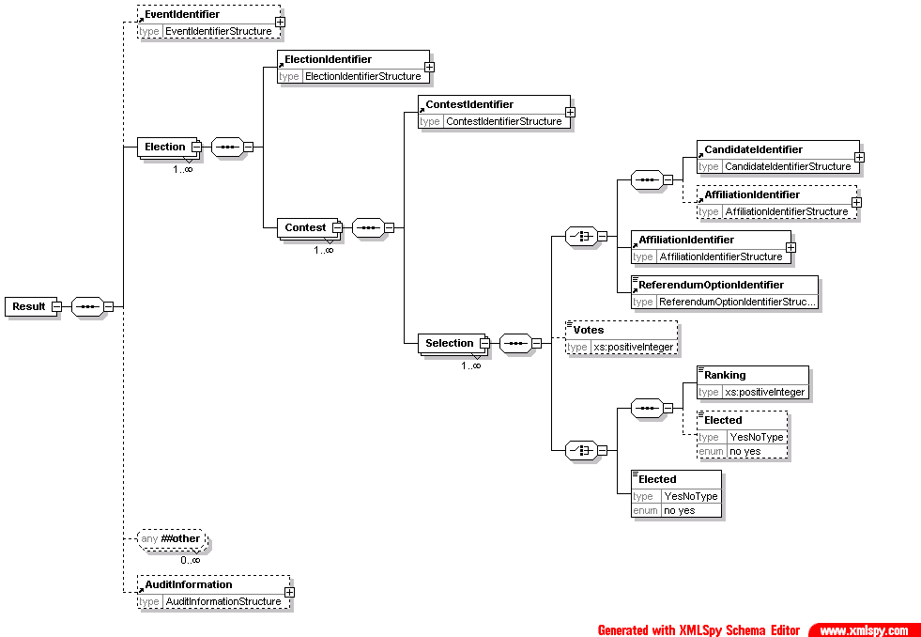

Description of Schema
Messages described by this schema can be used to communicate the results of simple election types. One specific use is to provide an input into the calculation algorithm for elections using the additional member system.
The main part of the schema is held within the Selection element. This allows a choice of candidate, affiliation or referendum option identifiers to be defined with the position that choice achieved (first, second etc). Optionally, the number of votes can be shown. A candidate can be associated with his or her affiliation if required. Write in candidates will be shown in the same way as other candidates, although they will only have an Id attribute if this is assigned in the election system after the votes are cast.

Description of UK Specifics

None identified.

610 - Options Nomination
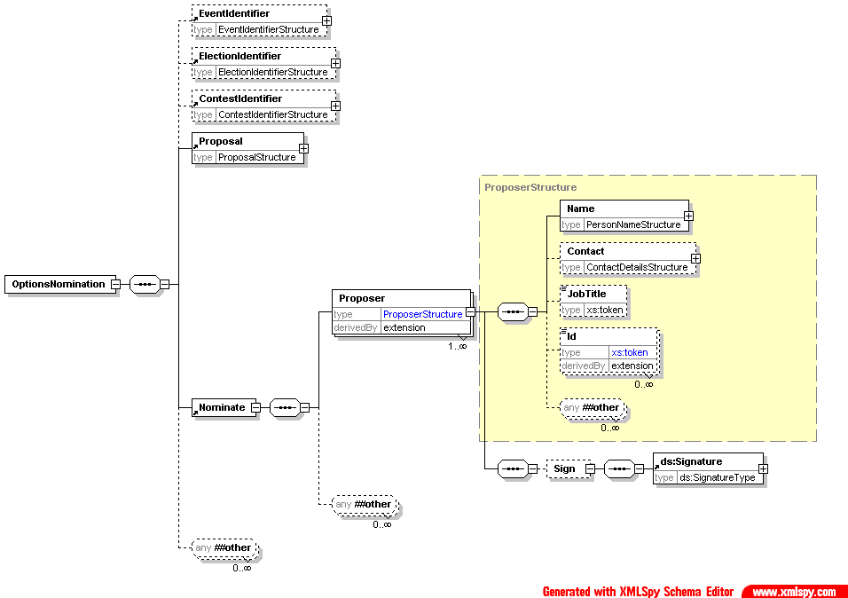

Description of Schema

This schema is used to submit proposals, for example for a referendum or company AGM. It uses the generic Proposal element to define the proposal itself. One of more proposers can be named and may sign the nomination.

Description of UK Specifics

Error Code | Error Description
4610-001 | Each proposer must have a contact method

620 - Options Nomination Response
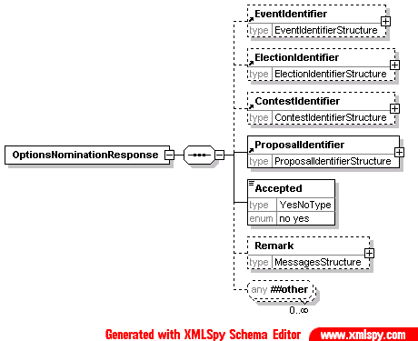

Description of Schema
This message is sent from the election organiser to the proposer to say whether the nomination has been accepted. Along with the acceptance information and the basic information of election, contest and identifier for the proposal, a remark can be made explaining the decision.

EML Schematron Rules

Error Code | Error Description
3620-001 | If the nomination has not been accepted, a reason for rejection is required in the Remark element

Description of UK Specifics

None identified.

630 - Options List

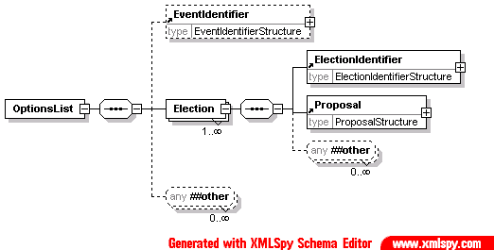

Description of Schema
This schema is used for messages transferring lists of proposals for a referendum. It may identify the election event, and provides details about the election. Each proposal in a referendum counts as an election, so each election identified will hold a single proposal.

Description of UK Specifics

None identified.

- Election Mark-up Language OASIS
see http://www.oasis-open.org/committees/election/

References

- XML Schema 1.0 W3C
http://www.w3.org/XML/Schema
- Address and Personal Details Schema Office of the e-Envoy
see http://www.govtalk.gov.uk/interoperability/draftschema_schema.asp?schemaid=92
- Standard Names and Codes for administrative and electoral geographies in the UK (SNAC) see http://www.statistics.gov.uk/geography/snac.asp
- XML-Signature Syntax and Processing W3C
http://www.w3.org/TR/xmldsig-core/
- RFC 2630 Cryptographic Message Syntax IETF
http://www.ietf.org/rfc/rfc2630.txt
- RFC 3161 Internet X.509 Public Key Infrastructure Time-Stamp Protocol (TSP) IETF
http://www.ietf.org/rfc/rfc3161.txt
- The Schematron Assertion Language 1.5
http://www.ascc.net/xml/schematron/
- ISO/IEC 19757 Document Schema Definition Languages ISO/IEC
see http://www.dsdl.org/
- XML Path Language (XPath) Version 1.0 W3C
http://www.w3.org/TR/xpath
- e-Voting Security Study Issue 1.2 (31 July 2002) CESG http://www.edemocracy.gov.uk/library/papers/study.pdf
- Government Data Standards Catalogue Office of the e-Envoy see http://www.govtalk.gov.uk/schemasstandards/eservices.asp

EML defines the data standard for the structured interchange of data among election systems, but it does not cover the interconnection requirements and transport protocol between systems. This is called the EML transport

Appendix A. EML-UK Transport - Proposal for Discussion
Standardising the interconnection required the full communication interface including all interconnection levels to be define: Physical, network, transport, networking (i.e. the TCP/IP stack), including the security elements provided at each level.

Message Size Limits
For the UK, file sizes should be limited to 50MB unless otherwise agreed between the exchanging parties. All systems should be capable of accepting files of this size and all those that process messages that can be split should be capable of dividing and reassembling messages that use the file splitting mechanism (see page 10).

EML-UK Transport Standards
Unless alternative standards are bilaterally agreed between vendors that meet the security requirements and targets, the following standards are mandated for EM-UK transport:
Transfer type | Inter-connectivity standards | Transport Protocol | EML Seal | Message Size | Security
Off line | N/A | N/A | Mandatory to support one of the seal Types defined in EML.  If the Seal is of type OtherSeal, then the Type attribute is required and must have a value of RFC2630 or RFC3161. | 600Mbytes  Maximum | As required by the Manual of Protective Security.
On line | Mandatory to conform to IPv4 (RFC 791) as defined in the e-GIF: | Mandatory to conform to one of the following protocols:  - Https:put  - SOAP  (i.e. simple SOAP) | Mandatory to support one of the seal Types defined in EML  If the Seal is of type OtherSeal, then the Type attribute is required and must have a value of RFC2630 or RFC3161 | 50Mbytes  Maximum | Mandatory to support one of the following  - TLS (RFC 2246) with mutual authentication and confidentiality as defined in CESG Manual T.  - IPSEC ESP (RFC 2406) confidentiality as defined in CESG manual V.  Note: whilst specifically the data you are protecting may not be classified. The spirit rather than the letter of Manual T & V should be met


© Crown Copyright 2003
The text in this document may be reproduced free of charge in any format or media without requiring specific permission. This is subject to the material not being used in a derogatory manner or in a misleading context. The source of the material must be acknowledged as Crown Copyright and the title of the document must be included when being reproduced as part of another publication or service.
Online copies of this document will be made available at: www.govtalk.gov.uk
Office of the e-Envoy, Stockley House, 130 Wilton Road, London, SW1V 1LQ
Email: govtalk@e-envoy.gsi.gov.uk

A reporting unit is an entity that reports partial information relating to a contest (votes or the results of a count) without having the full set of information required to generate a result. This will happen when votes from several independently managed areas must be amalgamated to produce a result.

